Learner Guide

Module 2 – Introduction to Mathematics and Statistics
Occupational Certificate: Artificial Intelligence Software Developer

Module # | 251201-002-00-KM-02
NQF Level | 4
Notional hours | 100
Credit(s) | 10
Curriculum Code | 251201002
Qualification Title | Occupational Certificate: Artificial Intelligence Software Developer
Development  Quality Partner | MICT SETA
Occupation or Specialization | AI Software Developer
Associated Occupation | Software Developer

CONTACT INFORMATION:
Name
Contact Address
Telephone (H)
Telephone (W)
Facsimile
Cellular
E-mail

Note to the learner
This Learner Guide provides a comprehensive overview of the module. It is designed to improve the skills and knowledge of learners, and thus enabling them to effectively and efficiently complete specific tasks.
PURPOSE OF THE KNOWLEDGE MODULE
The main focus of the learning in this knowledge module is to revise and acquire mathematical and statistical theory to successfully understand and interpret actions of Artificial Intelligence, Machine Learning, Deep Learning and Data Analytics

Entry Requirements:
NQF 4

PROVIDER ACCREDITATION REQUIREMENTS FOR THE MODULE:

Physical Requirements:
The provider must have lesson plans and structured learning material or provide learners with access to structured learning material that addresses all the topics in all the knowledge modules as well as the applied knowledge in the practical skills.
QCTO/ MICT SETA requirements
Human Resource Requirements:
Lecturer/learner ratio of 1:20 (Maximum)
Qualification of lecturer (SME):
NQF 6 in industry recognised qualifications with 1 year’s experience in the IT industry
AI vendor certification (where applicable)
Assessors and moderators: accredited by the MICT SETA
Legal Requirements:
Legal (product) licences to use the software for learning and training (where applicable)
OHS compliance certificate
Ethical clearance (where necessary)
Exemptions
No exemptions, but the module can be achieved in full through a normal RPL process

Assessments:

The only way to establish whether you are competent and have accomplished the learning outcomes is through continuous assessments. This assessment process involves interpreting evidence about your ability to perform certain tasks. You will be required to perform certain procedures and tasks during the training programme and will be assessed on them to certify your competence.

This module includes assessments in the form of self-evaluations/activities and exercises. The exercises, activities and self-assessments will be done in pairs, groups or on your own. These exercises/activities or self-assessments (Learner workbook) must be handed to the facilitator. It will be added to your portfolio of evidence, which will be proof signed by your facilitator that you have successfully performed these tasks.

Listen carefully to the instructions of the facilitator and do the given activities in the time given to you.

TOPIC ELEMENTS TO BE COVERED INCLUDE:
KM-02-KT01: Basic Mathematics
KM-02-KT02: Linear Algebra
KM-02-KT03: Conversion between decimal and binary systems
KM-02-KT04: Expressing size and magnitude
KM-02-KT05: Error in calculations
KM-02-KT06: Cartesian coordinate system
KM-02-KT07: Pythagorean theorem
KM-02-KT08: Increments
KM-02-KT09: Calculus
KM-02-KT10: Probabilities
KM-02-KT11: Statistics
KM-02-KT12: Bayes’ Theorem

SECTION 1: KM-02-KT01 : Basic Mathematics
Learning Outcome
- KT0101 Operator precedence:
    - Definition and terminology
    - Purpose and use
    - Order of operations (left to right)
    - Apply precedence – PEMDAS (BOMDAS)
    - Parentheses (Brackets)
    - Exponents (Order)
    - Multiply and divide
    - Add and subtract
    - Use of PEMDAS (BOMDAS)
- KT0102 Integer division:
    - Definition and terminology
    - Purpose and use
    - Rules on how to divide integers
    - Names and symbols for integer division
    - Software for integer division
- KT0103 Modulus:
    - Definition and terminology
    - Purpose and use of modulus
    - Modulus abbreviated as “mod”% application(==) application
    - Modulus in programming
- KT0104 Mixing Types:
    - Definition and terminology
    - Purpose and use of mixing types
    - Apply an operator
    - Combination with the order of operations
    - The order in which an expression is written
    - How a computer would evaluate some expressions that combine types
    - Casting

- KT0101 Operator precedence:
    - Definition and terminology
    - Purpose and use
    - Order of operations (left to right)
    - Apply precedence – PEMDAS (BOMDAS)
    - Parentheses (Brackets)
    - Exponents (Order)
    - Multiply and divide
    - Add and subtract
    - Use of PEMDAS (BOMDAS)

Basic math is nothing but the simple or basic concept related with mathematics. Generally, counting, addition, subtraction, multiplication and division are called the basic math operation. The other mathematical concept are built on top of the above 4 operations.

What are the basic topics in mathematics?
- Algebra.
- Arithmetic.
- Calculus.
- Geometry.
- Probability and Statistics.
- Number System.
- Set Theory.
- Trigonometry.

What is the purpose of basic maths?
Basic math skills are those that involve making calculations of amounts, sizes or other measurements. Core concepts like addition, subtraction, multiplication and division provide a foundation for learning and using more advanced math concepts.

The order of operations is a rule that tells the correct sequence of steps for evaluating a math expression. We can remember the order using PEMDAS: Parentheses, Exponents, Multiplication and Division (from left to right), Addition and Subtraction (from left to right).

Parentheses are smooth and curved ( ), brackets are square [ ], and braces are curly { }. In mathematics, they are mostly used for order of operations. The innermost parentheses are calculated first, followed by the brackets that form the next layer outwards, followed by braces that form a third layer outwards.


What are exponents in mathematics?
Definition of exponent
1 : a symbol written above and to the right of a mathematical expression to indicate the operation of raising to a power. 2a : one that expounds or interprets.

An exponent is a positive or negative number or 0 placed above and to the right of a quantity. It expresses the power to which the quantity is to be raised or lowered. In 4 ³, 3 is the exponent. It shows that 4 is to be used as a factor three times: 4 × 4 × 4 (multiplied by itself twice).

What is multiply and divide?

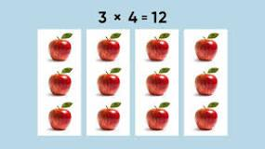

In multiplication, the numbers being multiplied are called factors; the result of the multiplication is called the product. In division, the number being divided is the dividend, the number that divides it is the divisor, and the result of the division is the quotient.

What is addition and subtraction in mathematics?
Definitions: Addition - A mathematical operation that represents combining objects t into a larger collection. It is signified by the plus sign (+). Subtraction - A mathematical operation that represents process of finding the difference between numbers or quantities. It is signified by the minus sign (-).

What do you use Pemdas for in math?
The order of operations is a rule that tells the correct sequence of steps for evaluating a math expression. We can remember the order using PEMDAS: Parentheses, Exponents, Multiplication and Division (from left to right), Addition and Subtraction (from left to right).

How do you use Bodmas rule in math?



The BODMAS rule states we should calculate the Brackets first (2 + 4 = 6), then the Orders (5² = 25), then any Division or Multiplication (3 x 6 (the answer to the brackets) = 18), and finally any Addition or Subtraction (18 + 25 = 43). Children can get the wrong answer of 35 by working from left to right.

- KT0102 Integer division:
    - Definition and terminology
    - Purpose and use
    - Rules on how to divide integers
    - Names and symbols for integer division
    - Software for integer division
Integer division is division in which the fractional part (remainder) is discarded is called integer division and is sometimes denoted . Integer division can be defined as , where "/" denotes normal division and is the floor function.

What is integer division example?
Division of integers means equal grouping or dividing an integer into a specific number of groups. For example, -6 ÷ 2 means dividing -6 into 2 equal parts, which results in -3.

The % (integer divide) operator divides two numbers and returns the integer part of the result. The result returned is defined to be that which would result from repeatedly subtracting the divisor from the dividend while the dividend is larger than the divisor.

What is the purpose of a division?
The main goal of the division is to see how many equal groups or how many in each group when sharing fairly.

RULE 1: The quotient of a positive integer and a negative integer is negative. RULE 2: The quotient of two positive integers is positive. RULE 3: The quotient of two negative integers is positive. If the signs are different the answer is negative.

What are the 4 rules for dividing integers?
What is the Rule of Division of Integers?
- Positive ÷ positive = positive.
- Negative ÷ negative = positive.
- Negative ÷ positive = negative.

What is the symbol of dividing?
(÷)
the symbol (÷) or (/) placed between two expressions and denoting division of the first by the second.

Names and symbols used for integer division include div, /, \, and %. Definitions vary regarding integer division when the dividend or the divisor is negative: rounding may be toward zero (so called T-division) or toward −∞ (F-division); rarer styles can occur – see Modulo operation for the details.
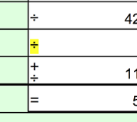

- KT0103 Modulus:
    - Definition and terminology
    - Purpose and use of modulus
    - Modulus abbreviated as “mod”% application(==) application
    - Modulus in programming
The modulus is another name for the remainder after division. For example, 17 mod 5 = 2, since if we divide 17 by 5, we get 3 with remainder 2. Modular arithmetic is sometimes called clock arithmetic, since analog clocks wrap around times past 12, meaning they work on a modulus of 12.

What is called modulus?
The modulo (or "modulus" or "mod") is the remainder after dividing one number by another. Example: 100 mod 9 equals 1. Because 100/9 = 11 with a remainder of 1. Another example: 14 mod 12 equals 2. Because 14/12 = 1 with a remainder of 2.

The modulus operator returns the remainder of a division of one number by another. In most programming languages, modulo is indicated with a percent sign. For example, "4 mod 2" or "4%2" returns 0, because 2 divides into 4 perfectly, without a remainder.

What is the purpose of modulus?
The modulus operator is useful in a variety of circumstances. It is commonly used to take a randomly generated number and reduce that number to a random number on a smaller range, and it can also quickly tell you if one number is a factor of another.

What is purpose of modulus operator mod?
The modulus operator - or more precisely, the modulo operation - is a way to determine the remainder of a division operation. Instead of returning the result of the division, the modulo operation returns the whole number remainder.

Is mod short for modulus?
An Introduction to Modular Math
Sometimes, we are only interested in what the remainder is when we divide A by B. For these cases there is an operator called the modulo operator (abbreviated as mod). We would say this as A modulo B is equal to R. Where B is referred to as the modulus.

What is the use of mod in maths?
In computing, the modulo operation returns the remainder or signed remainder of a division, after one number is divided by another (called the modulus of the operation).

- KT0104 Mixing Types:
    - Definition and terminology
    - Purpose and use of mixing types
    - Apply an operator
    - Combination with the order of operations
    - The order in which an expression is written
    - How a computer would evaluate some expressions that combine types
    - Casting

In mathematics, mixing is an abstract concept originating from physics: the attempt to describe the irreversible thermodynamic process of mixing in the everyday world: mixing paint, mixing drinks, industrial mixing, etc.
The concept appears in ergodic theory—the study of stochastic processes and measure-preserving dynamical systems. Several different definitions for mixing exist, including strong mixing, weak mixing and topological mixing, with the last not requiring a measure to be defined. Some of the different definitions of mixing can be arranged in a hierarchical order; thus, strong mixing implies weak mixing. Furthermore, weak mixing (and thus also strong mixing) implies ergodicity: that is, every system that is weakly mixing is also ergodic (and so one says that mixing is a "stronger" notion than ergodicity).

Why do we use mixed numbers?

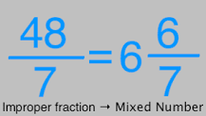

Mixed numbers are helpful when we are counting whole things and parts of things together.

What is meant by mathematical mixing?

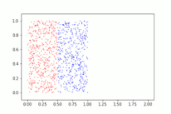

The mathematical definition of mixing aims to capture the ordinary every-day process of mixing, such as mixing paints, drinks, cooking ingredients, industrial process mixing, smoke in a smoke-filled room, and so on.

What is a mixed number in math example?
A mixed number is a combination of a whole number and a fraction. For example, if you have two whole apples and one half apple, you could describe this as 2 + ¹/2 apples, or 2¹/2 apples.

What is the operator in math?
In mathematics, an operator is generally a mapping or function that acts on elements of a space to produce elements of another space (possibly the same space, sometimes required to be the same space).

How do you use an operator in math?
operator, in mathematics, any symbol that indicates an operation to be performed. Examples are Square root of√x (which indicates the square root is to be taken) and ^{d}/_{dx} (which indicates differentiation with respect to x is to be performed).

Order of operations tells you to perform multiplication and division first, working from left to right, before doing addition and subtraction. Continue to perform multiplication and division from left to right. Next, add and subtract from left to right.

What is the order of operations in basic math?



The order of operations is a rule that tells the correct sequence of steps for evaluating a math expression. We can remember the order using PEMDAS: Parentheses, Exponents, Multiplication and Division (from left to right), Addition and Subtraction (from left to right).

In what order should an expression be simplified?

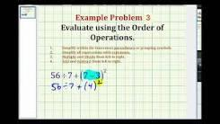

Simplify all expressions inside the parentheses or other grouping symbols, working on the innermost parentheses first.

How you can solve mathematical problems using computer programming?
Pay attention, here are the rules
- Understand the problem. Read the task carefully, try to understand it, and think about it deeply. ...
- Form an algorithm. Find the relation between the information given and what you want to find. ...
- Just make an algorithm! ...
- Look back at your solution. ...
- Understand. ...
- Make a plan. ...
- Execute it. ...
- Look back.

Internal Assessment Criteria and Weight
- IAC0101Operator precedence is explained in terms of application and used to solve an expression
- IAC0102Integer division is explained in terms of application and using correct terminology and symbols
- IAC0103Modulus is explained in terms of application and using correct terminology and symbols
- IAC0104Mixing types are explained in terms of application and using correct terminology and symbols

SECTION 2: KM-02-KT02: Linear Algebra
Learning Outcome
- KT0201 Linear transformation
- KT0202 Vectors:
  - Vectors
  - Customary behavioural vectors
  - Eigen vectors
- KT0203 Matrices:
  - Matrices
  - Inverse and transports
  - Special matrices
- KT0204 Matrix operations
- KT0205 Special functions in linear algebra:
  - ReLU
  - Sigmoid
  - SoftMax
  - Popular loss functions
  - Cross-entropy
  - Quadratic loss functions

- KT0201 Linear transformation
A linear transformation is a function from one vector space to another that respects the underlying (linear) structure of each vector space. A linear transformation is also known as a linear operator or map.

What is linear transformation with example?
Therefore T is a linear transformation. Two important examples of linear transformations are the zero transformation and identity transformation. The zero transformation defined by T(→x)=→(0) for all →x is an example of a linear transformation. Similarly the identity transformation defined by T(→x)=→(x) is also linear.

What is the linear transformation equation?

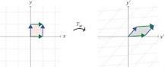

A plane transformation F is linear if either of the following equivalent conditions holds: F(x,y)=(ax+by,cx+dy) for some real a,b,c,d. That is, F arises from a matrix. For any scalar c and vectors v,w, F(cv)=cF(v) and F(v+w)=F(v)+F(w).

What are 4 different types of linear transformations?
While the space of linear transformations is large, there are few types of transformations which are typical. We look here at dilations, shears, rotations, reflections and projections.

How do linear transformations work?
It is simple enough to identify whether or not a given function f(x) is a linear transformation. Just look at each term of each component of f(x). If each of these terms is a number times one of the components of x, then f is a linear transformation.

- KT0202 Vectors:
  - Vectors
  - Customary behavioural vectors
  - Eigen vectors

A vector is an object that has both a magnitude and a direction. Geometrically, we can picture a vector as a directed line segment, whose length is the magnitude of the vector and with an arrow indicating the direction. The direction of the vector is from its tail to its head.

What are vectors examples?
Examples of vectors in nature are velocity, momentum, force, electromagnetic fields, and weight. (Weight is the force produced by the acceleration of gravity acting on a mass.) A quantity or phenomenon that exhibits magnitude only, with no specific direction, is called a Scalar .

What are 4 examples of vectors?
Examples of vector quantity include:
- Linear momentum.
- Acceleration.
- Displacement.
- Momentum.
- Angular velocity.
- Force.
- Electric field.
- Polarization.

What are vectors in maths?

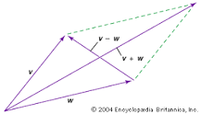

vector, in mathematics, a quantity that has both magnitude and direction but not position. Examples of such quantities are velocity and acceleration.

In linear algebra, an eigenvector (/ˈaɪɡənˌvɛktər/) or characteristic vector of a linear transformation is a nonzero vector that changes at most by a scalar factor when that linear transformation is applied to it. The corresponding eigenvalue, often denoted by {\displaystyle \lambda }\lambda , is the factor by which the eigenvector is scaled.

Geometrically, an eigenvector, corresponding to a real nonzero eigenvalue, points in a direction in which it is stretched by the transformation and the eigenvalue is the factor by which it is stretched. If the eigenvalue is negative, the direction is reversed.[1] Loosely speaking, in a multidimensional vector space, the eigenvector is not rotated.

What are eigen vectors?
The eigenvector is a vector that is associated with a set of linear equations. The eigenvector of a matrix is also known as a latent vector, proper vector, or characteristic vector. These are defined in the reference of a square matrix.

What is Eigen vector with example?
For example, suppose the characteristic polynomial of A is given by (λ−2)2. Solving for the roots of this polynomial, we set (λ−2)2=0 and solve for λ. We find that λ=2 is a root that occurs twice. Hence, in this case, λ=2 is an eigenvalue of A of multiplicity equal to 2.

- KT0203 Matrices:
  - Matrices
  - Inverse and transports
  - Special matrices

What are matrices used for?

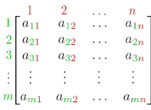

In geometry, matrices are widely used for specifying and representing geometric transformations (for example rotations) and coordinate changes. In numerical analysis, many computational problems are solved by reducing them to a matrix computation, and this involves often to compute with matrices of huge dimension.

What are the 4 types of matrices?

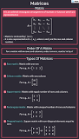

The various types of matrices are row matrix, column matrix, null matrix, square matrix, diagonal matrix, upper triangular matrix, lower triangular matrix, symmetric matrix, and antisymmetric matrix.

In mathematics and economics, transportation theory or transport theory is a name given to the study of optimal transportation and allocation of resources. The problem was formalized by the French mathematician Gaspard Monge in 1781.

In the 1920s A.N. Tolstoi was one of the first to study the transportation problem mathematically. In 1930, in the collection Transportation Planning Volume I for the National Commissariat of Transportation of the Soviet Union, he published a paper "Methods of Finding the Minimal Kilometrage in Cargo-transportation in space".

Major advances were made in the field during World War II by the Soviet mathematician and economist Leonid Kantorovich. Consequently, the problem as it is stated is sometimes known as the Monge–Kantorovich transportation problem. The linear programming formulation of the transportation problem is also known as the Hitchcock–Koopmans transportation problem.

Special Matrices publishes original articles of wide significance and originality in all areas of research involving structured matrices present in various branches of pure and applied mathematics and their noteworthy applications in physics, engineering, and other sciences.

What are the special types of matrices?
Special types of matrices, Square matrix, Diagonal matrix, Identity matrix, Transpose, Symmetric matrix. It is a square-shaped matrix with the same number of rows and columns.

What is the difference between identity matrix and scalar matrix?

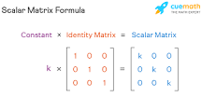

In an identity matrix, the principal diagonal elements are all equal to 1, and in a scalar matrix, all the principal diagonal elements are equal to a constant value.

- KT0204 Matrix operations
Matrix operations mainly involve three algebraic operations which are addition of matrices, subtraction of matrices, and multiplication of matrices. Matrix is a rectangular array of numbers or expressions arranged in rows and columns. Important applications of matrices can be found in mathematics.

What are three matrix operations?
The three operations are:
- Switching Rows.
- Multiplying a Row by a Number.
- Adding Rows.

What are the rules for matrix operations?
Rule of Matrix Algebra
- A+B = B+A →Commutative Law of Addition.
- A+B+C = A +(B+C) = (A+B)+C →Associative law of addition.
- ABC = A(BC) = (AB)C →Associative law of multiplication.
- A(B+C) = AB + AC →Distributive law of matrix algebra.
- R(A+B) = RA + RB.

What are the characteristics of a matrix operations?
Properties of Matrix Multiplication
- A(BC) = (AB)C associative.
- A(B + C) = AB + AC distributive.
- (A + B)C = AC + BC distributive.
- There are unique matrices I_{m} and I_{n} with. I_{m} A = A I_{n} = A multiplicative identity.

- KT0205 Special functions in linear algebra:
  - ReLU
  - Sigmoid
  - SoftMax
  - Popular loss functions
  - Cross-entropy
  - Quadratic loss functions

ReLU. The ReLU function is another non-linear activation function that has gained popularity in the deep learning domain. ReLU stands for Rectified Linear Unit. The main advantage of using the ReLU function over other activation functions is that it does not activate all the neurons at the same time.

What kind of function is ReLU?

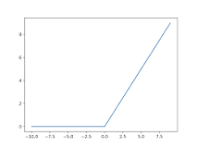

The rectified linear activation function or ReLU for short is a piecewise linear function that will output the input directly if it is positive, otherwise, it will output zero.

Sigmoid function
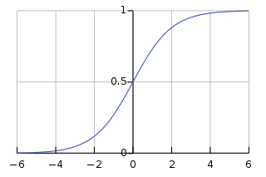
The logistic curve
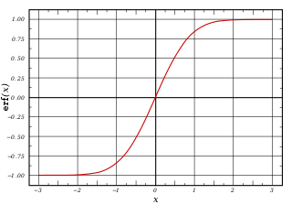
Plot of the error function
A sigmoid function is a mathematical function having a characteristic "S"-shaped curve or sigmoid curve.
A common example of a sigmoid function is the logistic function shown in the first figure and defined by the formula:

Other standard sigmoid functions are given in the Examples section. In some fields, most notably in the context of artificial neural networks, the term "sigmoid function" is used as an alias for the logistic function.
Special cases of the sigmoid function include the Gompertz curve (used in modeling systems that saturate at large values of x) and the ogee curve (used in the spillway of some dams). Sigmoid functions have domain of all real numbers, with return (response) value commonly monotonically increasing but could be decreasing. Sigmoid functions most often show a return value (y axis) in the range 0 to 1. Another commonly used range is from −1 to 1.
A wide variety of sigmoid functions including the logistic and hyperbolic tangent functions have been used as the activation function of artificial neurons. Sigmoid curves are also common in statistics as cumulative distribution functions (which go from 0 to 1), such as the integrals of the logistic density, the normal density, and Student's t probability density functions. The logistic sigmoid function is invertible, and its inverse is the logit function. The sigmoid function could generate some non-zero values, resulting in a dense representation.

Softmax function
The softmax function, also known as softargmax: 184 or normalized exponential function,: 198 is a generalization of the logistic function to multiple dimensions. It is used in multinomial logistic regression and is often used as the last activation function of a neural network to normalize the output of a network to a probability distribution over predicted output classes, based on Luce's choice axiom.
The softmax function takes as input a vector z of K real numbers, and normalizes it into a probability distribution consisting of K probabilities proportional to the exponentials of the input numbers. That is, prior to applying softmax, some vector components could be negative, or greater than one; and might not sum to 1; but after applying softmax, each component will be in the interval , and the components will add up to 1, so that they can be interpreted as probabilities. Furthermore, the larger input components will correspond to larger probabilities.

Loss function
In mathematical optimization and decision theory, a loss function or cost function (sometimes also called an error function) is a function that maps an event or values of one or more variables onto a real number intuitively representing some "cost" associated with the event. An optimization problem seeks to minimize a loss function. An objective function is either a loss function or its opposite (in specific domains, variously called a reward function, a profit function, a utility function, a fitness function, etc.), in which case it is to be maximized. The loss function could include terms from several levels of the hierarchy.

In statistics, typically a loss function is used for parameter estimation, and the event in question is some function of the difference between estimated and true values for an instance of data. The concept, as old as Laplace, was reintroduced in statistics by Abraham Wald in the middle of the 20th century. In the context of economics, for example, this is usually economic cost or regret. In classification, it is the penalty for an incorrect classification of an example. In actuarial science, it is used in an insurance context to model benefits paid over premiums, particularly since the works of Harald Cramér in the 1920s. In optimal control, the loss is the penalty for failing to achieve a desired value. In financial risk management, the function is mapped to a monetary loss.

Cross entropy
In information theory, the cross-entropy between two probability distributions and over the same underlying set of events measures the average number of bits needed to identify an event drawn from the set if a coding scheme used for the set is optimized for an estimated probability distribution , rather than the true distribution .

Internal Assessment Criteria and Weight

- IAC0201The definition of linear transformation, vectors, matrices and matrix operations is understood and the applications thereof described
- IAC0202The definition of special functions is understood and the applications thereof described

SECTION 3: KM-02-KT03 :Conversion between decimal and binary systems
Learning Outcome
- KT0301 Introduction to binary numbers
- KT0302 Perform addition and subtraction of positive whole numbers in binary
- KT0303 Binary arithmetic

- KT0301 Introduction to binary numbers
The binary system is a way of representing data using 0s and 1s. This system is used by computers to represent all the data it works with. To compute a number in this system, you would multiply the digit value by the place value, then add them all together.

How do you explain binary numbers?
binary number system, in mathematics, positional numeral system employing 2 as the base and so requiring only two different symbols for its digits, 0 and 1, instead of the usual 10 different symbols needed in the decimal system.

What is binary number example?
A method of representing numbers that has 2 as its base and uses only the digits 0 and 1. Each successive digit represents a power of 2. For example, 10011 represents (1 X 24) + (0 X 23) + (0 X 22) + (1 X 21) + (1 X 20), or 16 + 0 + 0 + 2 + 1, or 19.

Why are binary numbers used?
The binary number system is an alternative to the decimal (10-base) number system that we use every day. Binary numbers are important because using them instead of the decimal system simplifies the design of computers and related technologies.

- KT0302 Perform addition and subtraction of positive whole numbers in binary
How do you add positive and negative numbers in binary?
Using two's complement for negative numbers
- Find the positive binary value for the negative number you want to represent.
- Add a 0 to the front of the number, to indicate that it is positive.
- Invert or find the complement of each bit in the number.
- Add 1 to this number.

How do you subtract 8 bit binary numbers?

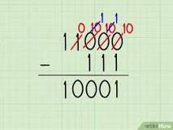

To subtract a larger number from a smaller one, switch the order of the numbers, do the subtraction, then add a negative sign to the answer. For example, to solve the binary problem 11 - 100, solve for 100 - 11 instead, then add a negative sign to the answer.

What are the rules of binary addition?
Rules of Binary Addition
- 0 + 0 = 0.
- 0 + 1 = 1.
- 1 + 0 = 1.
- 1 + 1 =10.

- KT0303 Binary arithmetic
Binary arithmetic includes the basic arithmetic operations of addition, subtraction, multiplication and division. The following sections present the rules that apply to these operations when they are performed on binary numbers. Binary Addition: Binary addition is performed in the same way as addition in the decimal-

Why is binary arithmetic?

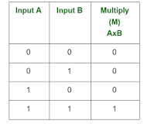

Binary arithmetic is an essential part of various digital systems. You can add, subtract, multiply, and divide binary numbers using various methods. These operations are much easier than decimal number arithmetic operations because the binary system has only two digits: 0 and 1.

How do you convert binary to arithmetic?
The step by step process to convert from the decimal to the binary system is:
- Find the largest power of 2 that lies within the given number.
- Subtract that value from the given number.
- Find the largest power of 2 within the remainder found in step 2.
- Repeat until there is no remainder.

What is binary arithmetic example?
1 + 0 = 1. 1 + 1 = 2 which is 10 in binary which is 0 with a carry of 1. 1 + 1 + 1 (carry) = 3 which is 11 in binary which is 1 with a carry of 1.

Internal Assessment Criteria and Weight
IAC0301Conversions between decimal and binary systems and the application thereof are
explained

SECTION 4: KM-02-KT04: Expressing size and magnitude
Learning Outcome
- KT0401 Use scientific notation for small and large numbers
- KT0402 Prefixes:
    - Giga to Pica (109 to 10 -12)
    - Conversions
- KT0403 SI to Imperial
- KT0404 Degrees F to degrees C

- KT0401 Use scientific notation for small and large numbers
Scientific notation is a way of writing very large or very small numbers. A number is written in scientific notation when a number between 1 and 10 is multiplied by a power of 10. For example, 650,000,000 can be written in scientific notation as 6.5 ✕ 10^8.

How do you write small numbers in scientific notation?
To write a small number (between 0 and 1) in scientific notation, you move the decimal to the right and the exponent will have to be negative. You may notice that the decimal point was moved five places to the right until you got the number 4, which is between 1 and 10. The exponent is −5.

Why do scientific notation represent small and large numbers?
There are two reasons to use scientific notation in chemistry. The first is to reveal honest uncertainty in experimental measurements. The second is to express very large or very small numbers so they are easier to read.

How do you write 2.0 in scientific notation?

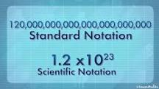

If you wanted to express this sum in scientific notation, you'd write 2.0 x 10³. Here's how we made that conversion. When you use scientific notation, what you're really doing is taking a small number (i.e., 2.0) and multiplying it by a specific exponent of 10 (i.e., 10³).

- KT0402 Prefixes:
    - Giga to Pica (109 to 10 -12)
    - Conversions

To convert a smaller unit to a larger unit (eg to ), divide it by the number of smaller units which are needed to make larger unit. To convert from a larger unit to a smaller one, multiply. To convert from a smaller unit to a larger one, divide.

What kind of math is conversions?
By definition conversion of units means the conversion between different units and measurements of the same quantity done by the process of multiplication or division. In maths, conversion is the process of changing the value of one form to another for example inches to millimeters, or liters to gallons.

What are the 7 basic units of measurement?

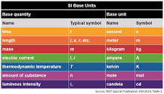

The seven SI base units, which are comprised of:
- Length - meter (m)
- Time - second (s)
- Amount of substance - mole (mole)
- Electric current - ampere (A)
- Temperature - kelvin (K)
- Luminous intensity - candela (cd)
- Mass - kilogram (kg)

- KT0403 SI to Imperial
Use the following information to convert conventional units of measure to SI units when you review laboratory test results. The conversion factor (CF) is used as follows: conventional unit × CF = SI unit. SI unit ÷ CF = conventional unit.

Are SI units similar to the imperial system?
While the main difference between the metric system and the imperial system is the type of units used, there are a few other key differences.
...
Fundamental Units Comparison Chart.
Measurement | Metric Units | Imperial Units
short length | centimeter/centimetre | foot, inch
mass/weight | gram | ounce, pound

How do you convert SI to Imperial?
If you memorize the most common conversion rates, you will be able to convert between most SI units and imperial units. (You can use Flashbulb to create flashcards that will help you memorize these rates.)
...
Imperial | SI
1 mile | 1.6 km
3.3 feet | 1 meter
1 inch | 2.54 cm

- KT0404 Degrees F to degrees C

Celsius and Fahrenheit are two temperature scales. The Fahrenheit and Celsius scales have one point at which they intersect. They are equal at -40 °C and -40 °F.

How do you convert F to C without a calculator?
Fahrenheit to Celsius Exact Formula
- Start with the temperature in Fahrenheit (e.g., 100 degrees).
- Subtract 32 from this figure (e.g., 100 - 32 = 68).
- Divide your answer by 1.8 (e.g., 68 / 1.8 = 37.78)

The temperature conversion is easy to do:
- Take the °F temperature and subtract 32.
- Multiply this number by 5.
- Divide this number by 9 to obtain your answer in °C.

What's the difference between Celsius and Fahrenheit? It's really a quirk of history and a simple mathematical conversion. Learn the easiest way to convert Fahrenheit to Celsius as well as the reverse calculation with simple equations and a chart.


Converting Fahrenheit to Celsius
Some would consider a quick estimate the easiest way to convert a Fahrenheit temperature to a Celsius temperature. Others want a more precise answer quickly. Here, you can learn both methods.
Fahrenheit to Celsius Estimate Formula
Use this formula to get a good estimate of the Celsius temperature when converting from Fahrenheit. In this case / means divided by or to use division.
(Fahrenheit temp. [F]-30)/2 = Celsius temp.
In other words, if you’d like to convert a Fahrenheit temperature to an approximate Celsius temperature:
- Start with the temperature in Fahrenheit (e.g., 100 degrees).
- Subtract 30 from this figure (e.g., 100 - 30 = 70).
- Divide your answer by 2 (e.g., 70 / 2 = 35).
Fahrenheit to Celsius Exact Formula
If you want a more precise calculation, you can use the more exact formula. Using this calculation, we determine that 100 degrees Fahrenheit is equivalent to 37.78 degrees Celsius.
(F - 32) / 1.8 = C
In other words, if you'd like to convert a temperature reading in Fahrenheit to Celsius:
- Start with the temperature in Fahrenheit (e.g., 100 degrees).
- Subtract 32 from this figure (e.g., 100 - 32 = 68).
- Divide your answer by 1.8 (e.g., 68 / 1.8 = 37.78)

Internal Assessment Criteria and Weight

- IAC0401Different ways to express size and magnitude are explained

SECTION 5: KM-02-KT05: Error in calculations
Learning Outcome
- KT0501 Rational and irrational numbers
- KT0502 Explore repeating decimals and convert them to fraction
- KT0503 Symbols for irrational numbers
- KT0504 Rounding prematurely in calculations
- KT0505 Accuracy in calculations
- KT0506 Final value of a calculation expressed in terms of the required unit
- KT0507 When PEMDAS fail

- KT0501 Rational and irrational numbers

Rational and Irrational numbers both are real numbers but different with respect to their properties. A rational number is the one which can be represented in the form of P/Q where P and Q are integers and Q ≠ 0. But an irrational number cannot be written in the form of simple fractions. ⅔ is an example of a rational number whereas √2 is an irrational number.
Let us learn more here with examples and the difference between them.

Definitions
What is a Rational number?
Rational numbers are numbers which can be expressed as a fraction and also as positive numbers, negative numbers and zero. It can be written as p/q, where q is not equal to zero.
The word “rational” is derived from the word ‘ratio’, which actually means a comparison of two or more values or integer numbers and is known as a fraction. In simple words, it is the ratio of two integers.
Example: 3/2 is a rational number. It means integer 3 is divided by another integer 2.
Get more information about rational numbers here.
What is an Irrational Number?
The numbers which are not rational numbers are called irrational numbers. Now, let us elaborate, irrational numbers could be written in decimals but not in the form of fractions, which means they cannot be written as the ratio of two integers.
Irrational numbers have endless non-repeating digits after the decimal point. Below is an example of an irrational number:
Example: √8 = 2.828…
How to Classify Rational and Irrational Numbers?
Let us see how to identify rational and irrational numbers based on the given set of examples.
As per the definition, rational numbers include all integers, fractions and repeating decimals. For every rational number, we can write them in the form of p/q, where p and q are integer values.
Venn Diagram
The below image shows the Venn diagram of rational and irrational numbers which come under real numbers.
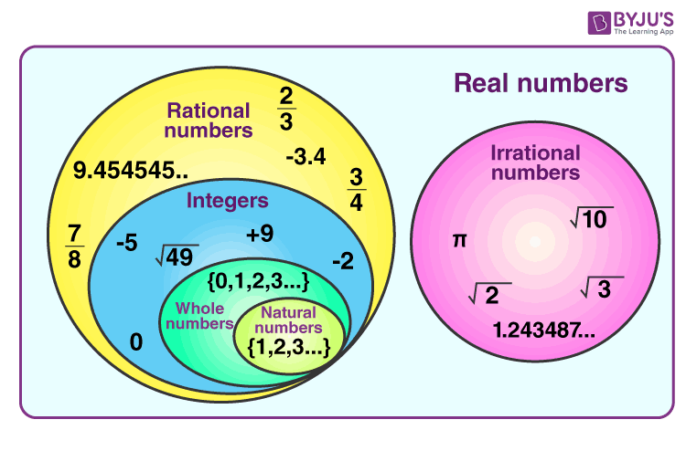
Difference Between Rational and Irrational Numbers
Rational Numbers | Irrational Numbers
It is expressed in the ratio, where both numerator and denominator are the whole numbers | It is impossible to express irrational numbers as fractions or in a ratio of two integers
It includes perfect squares | It includes surds
The decimal expansion for rational numbers executes finite or recurring decimals | Here, non-terminating and non-recurring decimals are executed

Examples
A list of examples of rational and irrational numbers is given here.
Examples of Rational Numbers
- Number 9 can be written as 9/1 where 9 and 1 both are integers.
- 0.5 can be written as ½, 5/10 or 10/20 and in the form of all termination decimals.
- √81 is a rational number, as it can be simplified to 9 and can be expressed as 9/1.
- 0.7777777 is recurring decimals and is a rational number
Examples of Irrational Numbers
Similarly, as we have already defined that irrational numbers cannot be expressed in fraction or ratio form, let us understand the concepts with a few examples.
- 5/0 is an irrational number, with the denominator as zero.
- π is an irrational number that has a value of 3.142…and is a never-ending and non-repeating number.
- √2 is an irrational number, as it cannot be simplified.
- 0.212112111…is a rational number as it is non-recurring and non-terminating.
There are a lot more examples apart from the above-given examples, which differentiate rational numbers and irrational numbers.

- KT0502 Explore repeating decimals and convert them to fraction
Rational numbers, when written as decimals, are either terminating or non-terminating, repeating decimals. Converting terminating decimals into fractions is straightforward: multiplying and dividing by an appropriate power of ten does the trick. For example, 2.556753 = \frac{2556753}{1000000}.2.556753=
1000000
2556753
​
. However, when the decimals are repeating, things are a little more difficult. Repeating decimals occur very frequently both when doing simple arithmetic and when solving competition problems, so being able to convert them to fractions is a valuable skill.

Repeating Decimal Number Line Placement
TRY IT
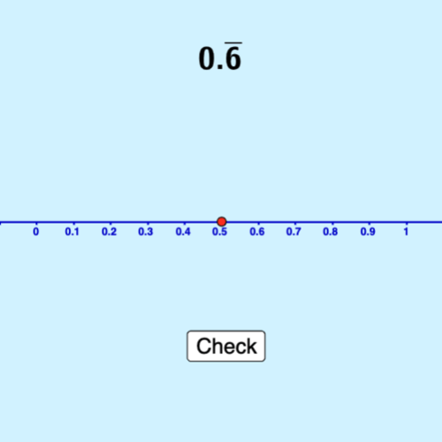
Inline Questions: Students see inline questions here. The questions are formative and have detailed instructional feedback. The questions and correct answers are printed below for your convenience as an instructor.
1. The following numbers are .7⎯⎯⎯7¯ rounded to different places. They all represent.7⎯⎯⎯⎯⎯.7¯ , but which one has the higher degree of accuracy?
Multiple Choice: .77778
2. The interactive shows how a number such as.3⎯⎯⎯⎯⎯.3¯ can be represented with higher accuracy. Which answer below has higher accuracy than .33333?
Multiple Choice: .333333
3. Use the interactive to see how you can zoom closer and closer to the number line. True or False? You can plot a number with a repeating decimal in its exact spot on the number line. You just have to zoom in far enough.
True or False: FALSE
This is false because you will always be able to zoom in (increasing the length of the decimal) to get a more accurate answer.

- KT0503 Symbols for irrational numbers
Generally, the symbol used to represent the irrational symbol is “P”. Since the irrational numbers are defined negatively, the set of real numbers (R) that are not the rational number (Q), is called an irrational number. The symbol P is often used because of the association with the real and rational number.

Irrational Numbers
Irrational numbers are those real numbers that cannot be represented in the form of a ratio. In other words, those real numbers that are not rational numbers are known as irrational numbers. Hippasus, a Pythagorean philosopher, discovered irrational numbers in the 5th century BC. Unfortunately, his theory was ridiculed and he was thrown into the sea. But irrational numbers exist, let's have a look at this page to get a better understand of the concept, and trust us, you won't be thrown into the sea. Rather, by knowing the concept, you will also know the irrational number list, the difference between irrational and rational numbers, and whether or not irrational numbers are real numbers.
What are Irrational Numbers?
Irrational numbers are the set of real numbers that cannot be expressed in the form of a fraction, p/q where p and q are integers. The denominator q is not equal to zero (q ≠ 0). Also, the decimal expansion of an irrational number is neither terminating nor repeating.
Irrational Numbers Definition: Irrational numbers are real numbers that cannot be represented as a simple fraction. These cannot be expressed in the form of ratio, such as p/q, where p and q are integers, q≠0. It is a contradiction of rational numbers.
Common Examples of Irrational Numbers
Given below are the few specific irrational numbers that are commonly used.
- ㄫ(pi) is an irrational number. π=3⋅14159265… The decimal value never stops at any point. Since the value of ㄫ is closer to the fraction 22/7, we take the value of pi as 22/7 or 3.14 (Note: 22/7 is a rational number.)
- √2 is an irrational number. Consider a right-angled isosceles triangle, with the two equal sides AB and BC of length 1 unit. By the Pythagoras theorem, the hypotenuse AC will be √2. √2=1⋅414213⋅⋅⋅⋅
- Euler's number e is an irrational number. e=2⋅718281⋅⋅⋅⋅
- Golden ratio, φ 1.61803398874989….

- KT0504 Rounding prematurely in calculations
A rounding error, or round-off error, is a mathematical miscalculation or quantization error caused by altering a number to an integer or one with fewer decimals.

What is the effect of rounding a number prematurely when completing calculations for business practices and investments?
The primary rationale of rounding in accounting is to provide a more accurate assessment of a company's financial state. However, if the rounding is done incorrectly it can result in an inaccurate assessment and presentation of a company's financial state.

What is rounding error in numerical methods?
Rounding error is the difference between a rounded-off numerical value and the actual value. A rounded quantity is represented by a numeral with a fixed number of allowed digits, with the last digit set to the value that produces the smallest difference between the rounded quantity and the actual quantity.

What is the rounding rule for statistical calculations?
With traditional rounding, if the number has a value less than the half-way mark between the possible outcomes, it is rounded down; if the number has a value exactly half-way or greater than half-way between the possible outcomes, it is rounded up.

- KT0505 Accuracy in calculations
The accuracy is a measure of the degree of closeness of a measured or calculated value to its actual value. The percent error is the ratio of the error to the actual value multiplied by 100. The precision of a measurement is a measure of the reproducibility of a set of measurements.

How do you calculate accuracy in data mining?

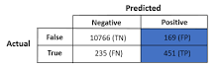

Accuracy
The accuracy of a classifier is given as the percentage of total correct predictions divided by the total number of instances. If the accuracy of the classifier is considered acceptable, the classifier can be used to classify future data tuples for which the class label is not known.

What is difference between accuracy and precision?

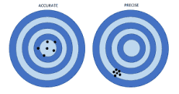

Accuracy reflects how close a measurement is to a known or accepted value, while precision reflects how reproducible measurements are, even if they are far from the accepted value. Measurements that are both precise and accurate are repeatable and very close to true values.

- KT0506 Final value of a calculation expressed in terms of the required unit

Final Value Theorem of Z-Transform
Z-Transform
The Z-transform is a mathematical tool which is used to convert the difference equations in discrete time domain into the algebraic equations in z-domain. Mathematically, if x(n)x(n) is a discrete time function, then its Z-transform is defined as,
Z[x(n)]=X(z)=∑n=−∞∞x(n)z−nZ[x(n)]=X(z)=∑n=−∞∞x(n)z−n
Final Value Theorem of Z-Transform
The final value theorem of Z-transform enables us to calculate the steady state value of a sequence x(n)x(n), i.e., x(∞)x(∞) directly from its Z-transform, without the need for finding its inverse Z-transform.
Statement - If x(n)x(n) is a causal sequence, then the final value theorem of Z-transform states that if,
x(n)↔ZTX(z)x(n)↔ZTX(z)
And if the Z-transform X(z) has no poles outside the unit circle, and it has no higher poles on the unit circle centred at the origin of the z-plane, then,
x(∞)=limn→∞x(n)=limz→1(z−1)X(z)x(∞)=limn→∞x(n)=limz→1(z−1)X(z)
Proof
From the definition of Z-transform of a causal sequence, we have,
Z[x(n)]=X(z)=∑n=0∞x(n)z−nZ[x(n)]=X(z)=∑n=0∞x(n)z−n
And
Z[x(n+1)]=∑n=0∞x(n)z−n=zX(z)−zx(0)Z[x(n+1)]=∑n=0∞x(n)z−n=zX(z)−zx(0)
∴Z[x(n+1)]−Z[x(n)]=∑n=0∞x(n)z−n−∑n=0∞x(n)z−n∴Z[x(n+1)]−Z[x(n)]=∑n=0∞x(n)z−n−∑n=0∞x(n)z−n
⇒Z[x(n+1)]−Z[x(n)]=zX(z)−zx(0)−X(z)⇒Z[x(n+1)]−Z[x(n)]=zX(z)−zx(0)−X(z)
∴(z−1)X(z)−zx(0)=∑n=0∞[x(n+1)−x(n)]z−n∴(z−1)X(z)−zx(0)=∑n=0∞[x(n+1)−x(n)]z−n
⇒(z−1)X(z)−zx(0)=[x(1)−x(0)]z0+[x(2)−x(1)]z−1+[x(3)−x(2)]z−2+...⇒(z−1)X(z)−zx(0)=[x(1)−x(0)]z0+[x(2)−x(1)]z−1+[x(3)−x(2)]z−2+...
Now taking limit z→1z→1 on both the sides, we get,
limz→1[(z−1)X(z)−zx(0)]=limz→1{[x(1)−x(0)]z0+[x(2)−x(1)]z−1+[x(3)−x(2)]z−2+...}limz→1[(z−1)X(z)−zx(0)]=limz→1{[x(1)−x(0)]z0+[x(2)−x(1)]z−1+[x(3)−x(2)]z−2+...}
⇒limz→1[(z−1)X(z)]−x(0)=x(1)−x(0)+x(2)−x(1)+x(3)−x(2)+...+x(∞)−x(∞−1)⇒limz→1[(z−1)X(z)]−x(0)=x(1)−x(0)+x(2)−x(1)+x(3)−x(2)+...+x(∞)−x(∞−1)
⇒limz→1[(z−1)X(z)]−x(0)=x(∞)−x(0)⇒limz→1[(z−1)X(z)]−x(0)=x(∞)−x(0)
∴x(∞)=limz→1[(z−1)X(z)]∴x(∞)=limz→1[(z−1)X(z)]
Numerical Example (1)
Find x(∞)x(∞) if X(z) is given by,
X(z)=z2(z−1)(z−0.3)X(z)=z2(z−1)(z−0.3)
Solution
The given Z-transform of the sequence is,
X(z)=z2(z−1)(z−0.3)X(z)=z2(z−1)(z−0.3)
Now, using the final value theorem for Z-transform [i.e,x(∞)=limz→1[(z−1)X(z)]][i.e,x(∞)=limz→1[(z−1)X(z)]] ,we get,
x(∞)=limz→1(z−1)[z2(z−1)(z−0.3)]=limz→1[z2(z−0.3)]x(∞)=limz→1(z−1)[z2(z−1)(z−0.3)]=limz→1[z2(z−0.3)]
∴x(∞)=[1(1−0.3)]=1.43∴x(∞)=[1(1−0.3)]=1.43
Numerical Example (2)
Using the final value theorem, calculate x(∞)x(∞) if X(z) is given by,
X(z)=z+13(z−1)(z+0.4)X(z)=z+13(z−1)(z+0.4)
Solution
The given Z-transform of the sequence is,
X(z)=z+13(z−1)(z+0.4)X(z)=z+13(z−1)(z+0.4)
∴(z−1)X(z)=z+13(z+0.4)∴(z−1)X(z)=z+13(z+0.4)
As we can see, (z−1)X(z)(z−1)X(z) has no poles on or outside the unit circle. Therefore, using the final value theorem for Z-transform, we have,
x(∞)=limz→1[z+13(z+0.4)]=[1+13(1+0.4)]x(∞)=limz→1[z+13(z+0.4)]=[1+13(1+0.4)]
∴x(∞)=[23×1.4]=0.48

- KT0507 When PEMDAS fail
PEMDAS is an acronym used for remembering the order of operations when writing and reading mathematics:
- Parentheses
- Exponents
- Multiplication
- Division
- Addition
- Subtraction
The order of operations tells us that in order to evaluate the expression 1+(6−4)31+(6−4)3, we should first perform the subtraction, then take the 3rd power, and finally add 1.1+(6−4)3=1+23=1+8=91+(6−4)3=1+23=1+8=9
As a general guideline, PEMDAS does a decent enough job of helping us interpret mathematical expressions properly. However, it does have a few failings when taken too literally.

The Social Media Problem
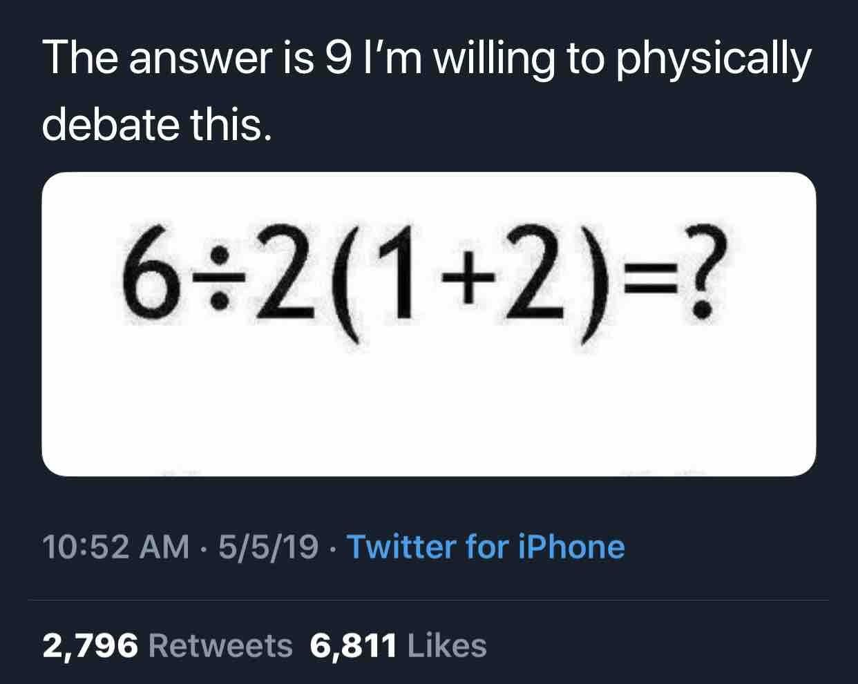
You know these math problems that pop up on social media all the time?
These types of problems tend to generate a lot of traffic. They entice many people to come together and discuss mathematics, which is great! The issue is that no one seems to know what the correct answer actually is. Well, many people think they know...
When confronted with the expression6÷2(1+2)6÷2(1+2)some people will swear by their mother's grave that the answer is 1, and others would challenge you to a duel to prove that the answer is 9.
Proponents of both sides of the argument will cite PEMDAS as the reason their answer is correct. But they both can't be correct, right? The truth is, 1 and 9 are both incorrect answers to this question.

Internal Assessment Criteria and Weight
- IAC0501The effect of error in calculations is reasoned

SECTION 6: KM-02-KT06: Cartesian coordinate system
Learning Outcome
- KT0601 Definition
- KT0602 Terminology
- KT0603 The coordinate plane:
    - Intersecting x- and y-axes
    - Four quadrants
- KT0604 Naming using Roman numerals
- KT0605 Use an application to create graphs and maps

- KT0601 Definition
A Cartesian coordinate system (UK: /kɑːˈtiːzjən/, US: /kɑːrˈtiʒən/) in a plane is a coordinate system that specifies each point uniquely by a pair of numerical coordinates, which are the signed distances to the point from two fixed perpendicular oriented lines, measured in the same unit of length.

- KT0602 Terminology

What is Cartesian coordinate system with example?

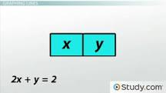

The Cartesian coordinate system uses a horizontal axis that is called the x-axis and a vertical axis called the y-axis. Equations for lines in this system will have both the x and y variable. For example, the equation 2x + y = 2 is an example of a line in this system.

- KT0603 The coordinate plane:
    - Intersecting x- and y-axes
    - Four quadrants

Coordinate graphing can sound very daunting for students in Grades 4–9, but it's actually just a visual method for showing relationships between numbers. The relationships are shown on a coordinate grid. A coordinate grid has two perpendicular lines, or axes (pronounced AX-eez), labeled just like number lines. The horizontal axis is usually called the x-axis. The vertical axis is usually called the y-axis. The point where the x- and y-axis intersect is called the origin.

What is the intersection of X and Y?

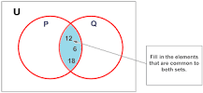

The intersection of two sets, X and Y, is the set of elements that are common to both X and Y. It is denoted by X ∩ Y, and is read "X intersect Y". So the intersection of two sets is the set of elements common to both sets.

What is the intersection of two axes of symmetry?
If it has two or multiple axes of symmetry, then its centroid will coincide with the intersection of those axes. The two shapes shown below demonstrate this fact. It is possible for the centroid of an object to be located outside of its geometric boundaries.

What are the 4 quadrants in math?
Here are the characteristics for each of the four coordinate plane quadrants:
- Quadrant I: positive x and positive y.
- Quadrant II: negative x and positive y.
- Quadrant III: negative x and negative y.
- Quadrant IV: positive x and negative y.

What is the rule for quadrant 4?
In the fourth quadrant, the values for cos are positive only. This can be summed up as follows: In the fourth quadrant, Cos is positive, in the first, All are positive, in the second, Sin is positive and in the third quadrant, Tan is positive.

- KT0604 Naming using Roman numerals
In naming the transition metal ion, add a Roman numeral in parenthesis after the name of the transition metal ion. The Roman numeral must have the same value as the charge of the ion. In our example, the transition metal ion Fe2+ would have the name iron(II). Add the name of the anion to the transition metal ion.

Which elements need Roman numerals in their name?
Several exceptions apply to the Roman numeral assignment: Aluminum, Zinc, and Silver.
...
Compounds between Metals and Nonmetals (Cation and Anion)
Transition Metal Ion with Roman Numeral | Latin name
Copper (II): Cu²⁺ | Cupric
Iron (II): Fe²⁺ | Ferrous
Iron (III): Fe³⁺ | Ferric
Lead (II): Pb²⁺ | Plumbous

Why do you put Roman numerals in compounds?
In chemistry nomenclature (writing names systematically), Roman numerals are used for a specific group of elements. These elements are called transition metals. And the Roman numerals indicate the charges that these metals carry in a compound.

What does the Roman numeral in a chemical name indicate?
They indicate the oxidation state of the element in the ion, usually a metal. If the compiund is ionic and the ion has only one atom, this is also the charge of the ion.

- KT0605 Use an application to create graphs and maps
Best Graph Making Apps
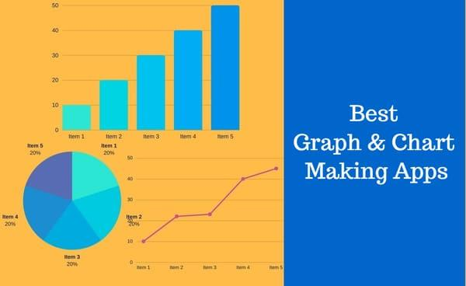
Graphs and charts are ideal for visually communicating complex data. There are tons of different apps and tools out there that let you make graphs from your own data.
Everybody knows how hard and exhausting can be to draw some charts and graphs, but how about making them directly with your mobile device from anywhere? That’s right, publishers have created apps and websites to simplify your life by cutting all the extra time that implied creating this drawings. So, we wrote the following article where we talk about the best apps available on the market that can help users create charts and graphs.

1. Canva
Canva is a popular app which lets users to create graphs or charts with tables, photos and graphics in minutes. All you have to do is enter your data to get instant results. Canva offers a range of free, designer-made templates. You can switch between different chart types like bar graphs, line graphs and pie charts without losing your data.
Graphs are customizable, so you can get the look you want: customize the colors, the fonts and the backgrounds with our simple drag and drop tools. Canva offers a huge range of templates for infographics, presentations and reports, so you can put your beautiful custom charts exactly where you need them. And you can publish your graphs exactly as you please: you can share, download, embed or even order professional prints.

2. Visme
Visme is easy-to-use online tool used by content creators for creating graphs, charts, infographics and a lot more. Visme is the only tool that allows you to create various forms of content as simple graphics but with a series of interactive features to bring static content to live such as ability to animate any object and assign actions.
Visme is a tool used by bloggers, educators, students and small businesses. There are more than 50 charts & graphs, interactive maps, plus media features with full privacy and collaboration tools.

3. Simple Graph Maker
Simple Graph Maker is a graph making app for Android devices that quickly creates charts and graphs. It’s so simple to create a graphic with this app, that all that you need to do is only to write in the labels and numbers. No more adding functions or doing other complex stuff, this awesome and minimalist application takes all the work out of the creation process and makes it for you.
Devices: Android
4. Piktochart
Piktochart is an online tool for creating graphs, charts, infographics, presentation slides, reports, flyers, posters, and more, for both print and online audiences. Combining charts, graphs, text, and built-in graphics, teachers and students can easily assemble and present information using the drag-and-drop interface. Students can also upload their own files to use. Although it's generally geared toward adults in the workplace creating business presentations, Piktochart clearly lends itself to student use, though much of the functionality is reserved for Pro accounts.

5. Desmos Graphing Calculator
If you are into Mathematics and you want to use your mobile device to resolve equations and create graphics for them, Graphing Calculator HD is the app for you. It has stunning graphics and capabilities, being able to plot a huge amount of functions, while having implemented a powerful scientific calculator.
The application supports over 40 trigonometric functions, such as asin, cos, sin, log10, ceil, root, nroot, rad2deg, floor, ln, max, min and much more.

6. Chartistic - Charting App
Zoho Chartistic is a free iPhone app that lets you make charts and we used it to find out whether it works for our charting needs. Zoho Chartistic is making it easy to create charts, and the app is certainly easy enough to use. Hit the + button to create a new chart, and the app asks you to choose one out of five types of charts. Each of these are represented by icons only, which is a good thing considering this app is for people new to making charts.

Internal Assessment Criteria and Weight

- •IAC0601The Cartesian coordinate system is explained in terms of application and using correct terminology

SECTION 7: KM-02-KT07:Pythagorean theorem
Learning Outcome
- KT0701 What is a theorem?
- KT0702 Definition of Pythagorean theorem
- KT0703 Finding the distance between two points
- KT0704 Terminology
- KT0705 Purpose
- KT0706 Determine the distance between two points on the Cartesian grid

- KT0701 What is a theorem?
Theorems are what mathematics is all about. A theorem is a statement which has been proved true by a special kind of logical argument called a rigorous proof.

What is the Pythagorean theorem in simple terms?
Definition of Pythagorean theorem
: a theorem in geometry: the square of the length of the hypotenuse of a right triangle equals the sum of the squares of the lengths of the other two sides.

What is a Pythagorean theorem and what is it used for?

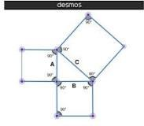

The Pythagorean Theorem is a useful tool that shows how the sum of the areas of three intersecting squares can determine the side lengths of a right triangle. This theorem is an extremely useful tool that provides the basis for more complex trigonometry theories such as the converse of the Pythagorean theorem.

What is the Pythagorean theorem answer?

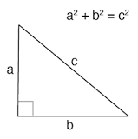

What is the Pythagorean Theorem? The Pythagorean Theorem states that the sum of the squared sides of a right triangle equals the length of the hypotenuse squared. If you know the length of any 2 sides of a right triangle you can use the Pythagorean equation formula to find the length of the third side.

- KT0702 Definition of Pythagorean theorem
Pythagorean theorem, the well-known geometric theorem that the sum of the squares on the legs of a right triangle is equal to the square on the hypotenuse (the side opposite the right angle)—or, in familiar algebraic notation, a² + b² = c².

What is the simple definition of Pythagorean Theorem?

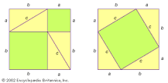

Pythagorean theorem, the well-known geometric theorem that the sum of the squares on the legs of a right triangle is equal to the square on the hypotenuse (the side opposite the right angle)—or, in familiar algebraic notation, a² + b² = c².

What is a Pythagorean Theorem triple?

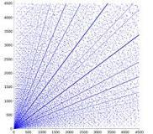

A Pythagorean triple consists of three positive integers a, b, and c, such that a² + b² = c². Such a triple is commonly written (a, b, c), and a well-known example is (3, 4, 5). If (a, b, c) is a Pythagorean triple, then so is (ka, kb, kc) for any positive integer k.

- KT0703 Finding the distance between two points
Learn how to find the distance between two points by using the distance formula, which is an application of the Pythagorean theorem. We can rewrite the Pythagorean theorem as d=√((x_2-x_1)²+(y_2-y_1)²) to find the distance between any two points.

Distance Between Two Points
Distance between two points is the length of the line segment that connects the two given points. Distance between two points in coordinate geometry can be calculated by finding the length of the line segment joining the given coordinates. Let us understand the formula to find the distance between two points in a two-dimensional and three-dimensional plane.

What is the Distance Between Two Points?
The distance between any two points is the length of the line segment joining the points. There is only one line passing through two points. So, the distance between two points can be calculated by finding the length of this line segment connecting the two points. For example, if A and B are two points and if ¯¯¯¯¯¯¯¯AB=10AB¯=10 cm, it means that the distance between A and B is 10 cm.
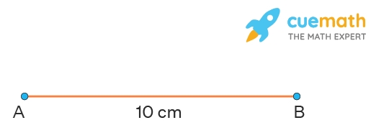
The distance between two points is the length of the line segment joining them (but this CANNOT be the length of the curve joining them). Note that the distance between two points is always positive.
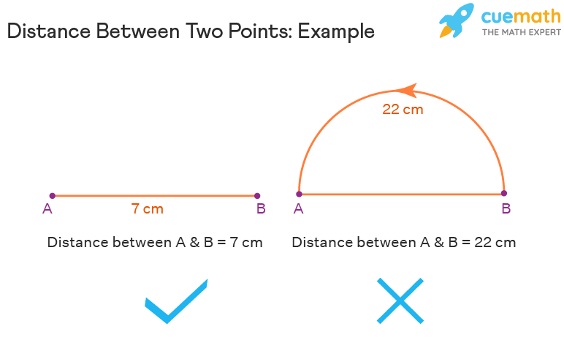
Distance Between Two Points Formula
The distance between two points using the given coordinates can be calculated by applying the distance formula. For any point given in the 2-D plane, we can apply the 2D distance formula or the Euclidean distance formula given as,
Formula for Distance Between Two Points:
The formula for the distance, dd, between two points whose coordinates are (x1,y1)(x1,y1) and (x2,y2(x2,y2) is:
d = √[(x2x2 − x1x1)² + (y2y2 − y1y1)²]

- KT0704 Terminology

What terms do you use for Pythagorean theorem?
Full list of words from this list:
- right triangle. a triangle with one right angle. ...
- coordinate system. a system that uses coordinates to establish position. ...
- theorem. an idea accepted as a demonstrable truth. ...
- hypotenuse. the side of a right triangle opposite the right angle. ...
- Pythagorean. ...
- dimensional. ...
- algebraic. ...
- geometry.

What are the 3 Pythagorean theorem?

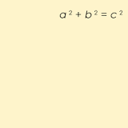

A Pythagorean triple consists of three positive integers a, b, and c, such that a² + b² = c². Such a triple is commonly written (a, b, c), and a well-known example is (3, 4, 5). If (a, b, c) is a Pythagorean triple, then so is (ka, kb, kc) for any positive integer k.

- KT0705 Purpose
The Pythagorean Theorem is a useful tool that shows how the sum of the areas of three intersecting squares can determine the side lengths of a right triangle. This theorem is an extremely useful tool that provides the basis for more complex trigonometry theories such as the converse of the Pythagorean theorem.

What is the Pythagorean theorem? It’s a trigonometry equation used to find the length of one side of a right triangle. Though similar concepts had been discovered by the Babylonians, Greek Mathematician Pythagoras was the first person to come up with a geometric proof about how the sum of the squares of the lengths can determine the side lengths of a right triangle.
Pythagoras determined that when three squares are arranged so that they form a right angle triangle, the largest of the three squares must have the same area as the other two squares combined. In the picture below, you can see how the sum of the squares creates the right triangle ABC.
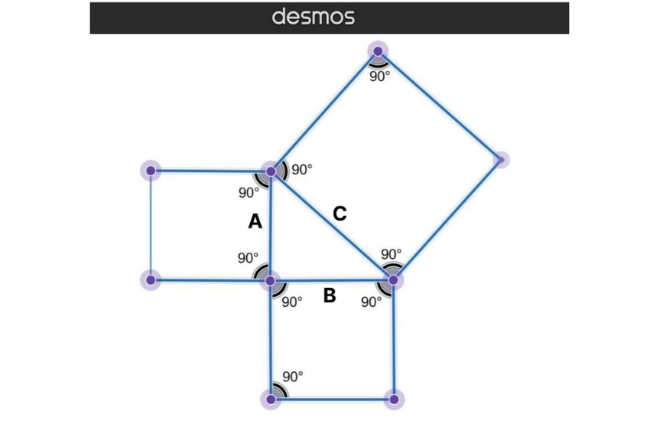
This realization about the area of the squares led to the Pythagoras theorem:
Squares are different from other parallelograms and trapezoids because all their sides are equal lengths. So since squares are made up of four equal sides, you can see that each individual square makes up a side of the right triangle.
The length of the largest square, which we'll call length c, is the length of the hypotenuse. (The hypotenuse is the longest side of a right triangle.) The smaller squares make up the other two sides of the right triangle.
Breaking Down the Pythagorean Theorem
Let's get into the dissection and proof of the Pythagorean theorem. The Pythagorean theorem states:
- The legs of a right triangle that are adjacent to a 90-degree angle must be squared and added together.

- KT0706 Determine the distance between two points on the Cartesian grid
For any two points, there's exactly one line segment connecting them. The distance between the two points is known to be the length of the line segment connecting them. Note that the distance between the two points is always positive. Segments which have the same length are called congruent segments. We can easily calculate the distance between two points. Take the coordinates of two points you would like to seek out space between. Call one point Point 1 (x1, y1) and make the opposite Point 2 (x2, y2). It doesn't terribly matter which point is which, as long as you retain the labels (1 and 2) consistent throughout the matter. Let’s discuss the distance formula.

How do you find the distance between two Cartesian points?

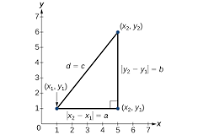

Derived from the Pythagorean Theorem, the distance formula is used to find the distance between two points in the plane. The Pythagorean Theorem, a2+b2=c2 a 2 + b 2 = c 2 , is based on a right triangle where a and b are the lengths of the legs adjacent to the right angle, and c is the length of the hypotenuse.

What is the distance between the two points on the grid?

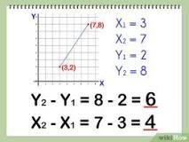

The linear distance between the two points is the square root of the sum of the squared values of the x-axis distance and the y-axis distance. To carry on the example: the distance between (3,2) and (7,8) is sqrt (52), or approximately 7.21 units.

How do you find the distance between two points using trigonometry?

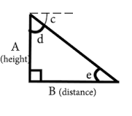

B (distance) = A (height) /tan ( e )
(tan is a trigonometric function which you should be able to find on a decent calculator, just make sure you are calculating using degrees not radians).

Internal Assessment Criteria and Weight

- IAC070 The definition of theorem is understood and the applications thereof described
- IAC0702The Pythagorean theorem is explained in terms of application and using correct terminology

SECTION 8: KM-02-KT08:Increments
Learning Outcome
- KT0801 Definition and terminology
- KT0802 Purpose and use of increments
- KT0803 Increment a variable
- KT0804 Compound assignment operator
- KT0805 Increments in programming

- KT0801 Definition and terminology
An increment is a small, unspecified, nonzero change in the value of a quantity. The symbol most commonly used is the uppercase Greek letter delta ( ). The concept is applied extensively in mathematical analysis and calculus.

How do you calculate increments?
If two points ( x1, y1 ) and ( x2, y2 ) lie on the graph of f(x), the increment in x ( Δx ) is the difference between x2 and x1. Similarly, the increment in y ( Δy ) is the different between y2 and y1. Let f(x) = x^2 - x + 2.

What are examples of increments?
The process of increasing or decreasing a numeric value by another value. For example, incrementing 2 to 10 by the number 2 would be 2, 4, 6, 8, 10. 2. An increment is also a programming operator to increase the value of a numerical value.

What is a mathematical terminology?
A term is a single mathematical expression. It may be a single number (positive or negative), a single variable ( a letter ), several variables multiplied but never added or subtracted. Some terms contain variables with a number in front of them. The number in front of a term is called a coefficient.

A term is a single mathematical expression.
It may be a single number (positive or negative), a single variable ( a letter ), several variables multiplied but never added or subtracted. Some terms contain variables with a number in front of them. The number in front of a term is called a coefficient.
Examples of single terms:
3x is a single term. The "3" is a coefficient. The "x" is the variable.
-5x2y3z4 is also a single term.
The"-5"isthecoefficient."xyz "arethevariablescomprisingtheterm.
12 is a single term.
It is simply a numerical term called a constant.
w is a single term too.
It is a single variable term and since there is only one "w" it has an implied coefficient of 1 .
We join terms together with addition to create expressions.
5x + 7y is a two termed expression.
The 5x is one term and the 7y is the second term. The two terms are separated by a plus sign.
234
7x y - 2xy + 7 is a three termed expression.
234
7x y is one term, - 2xy is the second term, and 7 is the third term.
The coefficient of the first term is 7.
The coefficient of the second term is negative 2. The third term is a constant, so it has no coefficient.
Like Terms
"Like terms" are terms which have variables which look EXACTLY alike.
3x2 and -7x2 are "like terms" because both terms have the variable x2
5x2y6z5, 13x2y6z5, and -21x2y6z5 are "like terms" because all of the terms have the variables "
265
xyz "inthem.
234
Combining Like Terms
To combine "like terms", combine the coefficients of terms which look exactly alike.
If you start with several terms separated by addition and subtraction signs, your answer should also contain addition and subtraction signs based on the signs obtained from doing the arithmetic.
Combine like terms:
22
3x +2x+9-2x +5x-3
22
3x +2x-9-2x +5x-3
2
(3-2)x +(2+5)x+(-9-3)
2
1x +7x+(-12)
2
1x +7x-12
You may be required to perform some other algebraic operations before you are ready to combine like terms.
Simplify. Combine like terms:
32 32
-5( 2x - 3x + 1) + 2(-2x + 5x - 1)
Distribute the -5 into the first parentheses and multiply. Do the same with the 2 in front of the second parentheses.
32 32
-5(2x ) -5(-3x ) -5(1) + 2(-2x ) + 2(5x ) + 2(-1)
3232 -10x +15x -5-4x +10x -2
Now combine like terms,
32 (-10-4)x +(15+10)x +(-5-2)
32 -14x +25x -7

- KT0802 Purpose and use of increments

Increment is used in many technical fields, but also nontechnically. Incremental increases in drug dosages are used for experimental purposes. Incremental tax increases are easier to swallow than sudden large increases. Incremental changes of any kind may be hard to notice, but can be very significant in the long run.

What does it mean to do something in increments?
(intransitive) To increase by steps or by a step, especially by one. 2. The definition of increment is the process of increasing by a specific amount, or the amount by which something increases. An example of an increment is an annual salary increase of 5%. noun.

What is the function of increment or decrement?
Increment increases the value in the selected operand by 1. Decrement decreases the value in the selected operand by 1. You can implement counters in your program by selecting a Counter (C) operand output type.

- KT0803 Increment a variable

To increment a variable means to increase it by the same amount at each change. For example, your coder may increment a scoring variable by +2 each time a basketball goal is made. Decreasing a variable in this way is known as decrementing the variable value.

The general format for incrementing or decrementing a variable value is as follows:
Action | Pseudocode | Examples
Increment a variable | variable = variable + change | score = score + 1  numTwins = numTwins + 2
Decrement a variable | variable = variable - change | timeRemaining = timeRemaining - 1  cost = cost - 5
Boolean variables aren't incremented nor decremented. A Boolean variable exists only in one of two states: true or false.

- KT0804 Compound assignment operator

The compound assignment operators consist of a binary operator and the simple assignment operator. They perform the operation of the binary operator on both operands and store the result of that operation into the left operand, which must be a modifiable lvalue.

What is compound assignment operators in C?
The compound-assignment operators combine the simple-assignment operator with another binary operator. Compound-assignment operators perform the operation specified by the additional operator, then assign the result to the left operand. For example, a compound-assignment expression such as. expression1 += expression2.

What's an example of a compound operator?
Like the “=” assignment operator, compound operators return the assigned result of the expression: long x = 1; long y = (x+=2); Both x and y will hold the value 3.

- KT0805 Increments in programming

An increment is also a programming operator to increase the value of a numerical value. In Perl, a variable can be incremented by one by adding a ++ at the end of the variable. In the example below, the value variable is set as 1 and then incremented in value by one with the $value++; line.

What is example of increment?
The definition of increment is the process of increasing by a specific amount, or the amount by which something increases. An example of an increment is an annual salary increase of 5%.

How do you code increments?
A common way to change a variable value is to increment it. To increment a variable means to increase it by the same amount at each change. For example, your coder may increment a scoring variable by +2 each time a basketball goal is made. Decreasing a variable in this way is known as decrementing the variable value.

Internal Assessment Criteria and Weight

- KT0901 Increments are explained in terms of application and using correct terminology and symbols

SECTION 9: KM-02-KT09: Calculus
Learning Outcome
- KT0901 Calculus essentials:
    - Differential calculus
    - Integral calculus
- KT0902 Derivatives:
    - Derivative and partial derivatives
    - Chain rule
    - Derivatives of special functions

- KT0901 Calculus essentials:
    - Differential calculus
    - Integral calculus

In calculus, the differential represents the principal part of the change in a function y = f(x) with respect to changes in the independent variable. The differential dy is defined by. where is the derivative of f with respect to x, and dx is an additional real variable (so that dy is a function of x and dx).

What is the difference between calculus and differential calculus?
While differential calculus focuses on rates of change, such as slopes of tangent lines and velocities, integral calculus deals with total size or value, such as lengths, areas, and volumes.

Integral calculus helps in finding the anti-derivatives of a function. These anti-derivatives are also called the integrals of the function. The process of finding the anti-derivative of a function is called integration. The inverse process of finding derivatives is finding the integrals.

What is integral calculus in simple terms?

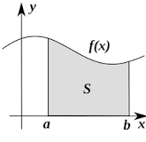

In calculus, an integral is the space under a graph of an equation (sometimes said as "the area under a curve"). An integral is the reverse of a derivative, and integral calculus is the opposite of differential calculus. A derivative is the steepness (or "slope"), as the rate of change, of a curve.

Where is integral calculus used?

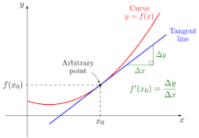

Applications of integral calculus include computations involving area, volume, arc length, center of mass, work, and pressure. More advanced applications include power series and Fourier series. Calculus is also used to gain a more precise understanding of the nature of space, time, and motion.

- KT0902 Derivatives:
    - Derivative and partial derivatives
    - Chain rule
    - Derivatives of special functions

In mathematics, a partial derivative of a function of several variables is its derivative with respect to one of those variables, with the others held constant (as opposed to the total derivative, in which all variables are allowed to vary). Partial derivatives are used in vector calculus and differential geometry.

What is difference between derivative and partial derivative?
The total derivative is a derivative of a compound function, just as your first example, whereas the partial derivative is the derivative of one of the variables holding the rest constant.

What is a partial derivative used for?
partial derivative, In differential calculus, the derivative of a function of several variables with respect to change in just one of its variables. Partial derivatives are useful in analyzing surfaces for maximum and minimum points and give rise to partial differential equations.

What is the difference between partial derivative and gradient?
The gradient is the derivative of a function Rm→R, as explained at stats.stackexchange.com/a/257616/919. As such it is a linear form on Rm. It is defined without reference to any particular basis of Rm. The partial derivatives are the derivatives of functions R→R defined by holding all but one variable fixed.

Internal Assessment Criteria and Weight

•IAC0901The definition of calculus is understood and the applications thereof described

SECTION 10: KM-02-KT10: Probabilities
Learning Outcome
- KT1001 Definition and terminology
- KT1002 Probability essentials
- KT1003 Probability basics and notations
- KT1004 Probabilities and odds
- KT1005 Probability:
    - Why probability matters
    - Odds
- KT1006 The Bayes rule:
    - Essential probability theorem
    - How odds change
    - Bayes rule in practice
    - Naïve Bayes classification
- KT1007 What are parameters
- KT1008 Estimating parameters
- KT1009 Conditional probability
- KT1010 Essential probability theorems for ML

- KT1001 Definition and terminology
Probability is a measure that is associated with how certain we are of outcomes of a particular experiment or activity. An experiment is a planned operation carried out under controlled conditions. If the result is not predetermined, then the experiment is said to be a chance experiment.

What are all the terms for probability?
Terms
- Event. A subset of the outcomes of a process. ...
- Complementary Events. Events whose probabilities add up to 1. ...
- Odds. The ratio of the probability of an event to the probability of its complement; i.e., the ratio of favorable outcomes to unfavorable outcomes.
- Outcomes. The possible results of an event. ...
- Probability.

What are the 3 types of probability?

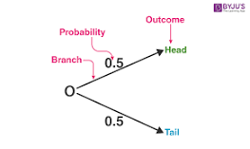

There are three major types of probabilities:
- Theoretical Probability.
- Experimental Probability.
- Axiomatic Probability.

- KT1002 Probability essentials

Probability Theory Example
The number of favorable outcomes is 1. The possible outcomes of the dice are {1, 2, 3, 4, 5, 6}. This implies that there are a total of 6 outcomes. Thus, the probability of obtaining 4 on a dice roll, using probability theory, can be computed as 1 / 6 = 0.167.

Probability Theory Basics
There are some basic terminologies associated with probability theory that aid in the understanding of this field of mathematics.
Random Experiment
A random experiment, in probability theory, can be defined as a trial that is repeated multiple times in order to get a well-defined set of possible outcomes. Tossing a coin is an example of a random experiment.
Sample Space
Sample space can be defined as the set of all possible outcomes that result from conducting a random experiment. For example, the sample space of tossing a fair coin is {heads, tails}.
Event
Probability theory defines an event as a set of outcomes of an experiment that forms a subset of the sample space. The types of events are given as follows:
- Independent events: Events that are not affected by other events are independent events.
- Dependent events: Events that are affected by other events are known as dependent events.
- Mutually exclusive events: Events that cannot take place at the same time are mutually exclusive events.
- Equally likely events: Two or more events that have the same chance of occurring are known as equally likely events.
- Exhaustive events: An exhaustive event is one that is equal to the sample space of an experiment.
Random Variable
In probability theory, a random variable can be defined as a variable that assumes the value of all possible outcomes of an experiment. There are two types of random variables as given below.
- Discrete Random Variable: Discrete random variables can take an exact countable value such as 0, 1, 2... It can be described by the cumulative distribution function and the probability mass function.
- Continuous Random Variable: A variable that can take on an infinite number of values is known as a continuous random variable. The cumulative distribution function and probability density function are used to define the characteristics of this variable.
Probability
Probability, in probability theory, can be defined as the numerical likelihood of occurrence of an event. The probability of an event taking place will always lie between 0 and 1. This is because the number of desired outcomes can never exceed the total number of outcomes of an event. Theoretical probability and empirical probability are used in probability theory to measure the chance of an event taking place.
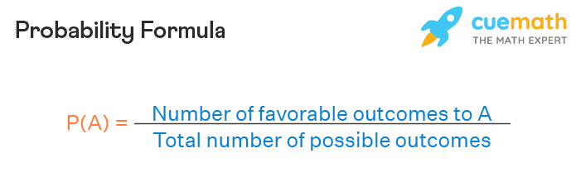
Conditional Probability
When the likelihood of occurrence of an event needs to be determined given that another event has already taken place, it is known as conditional probability. It is denoted as P(A | B). This represents the conditional probability of event A given that event B has already occurred.
Expectation
The expectation of a random variable, X, can be defined as the average value of the outcomes of an experiment when it is conducted multiple times. It is denoted as E[X]. It is also known as the mean of the random variable.

- KT1003 Probability basics and notations

What is the basic probability notation?

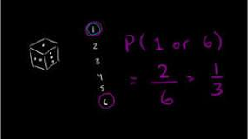

The probability of an event can only be between 0 and 1 and can also be written as a percentage. The probability of event A is often written as P ( A ) P(A) P(A)P, left parenthesis, A, right parenthesis.

What are the 5 basic probability rules?

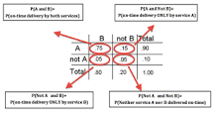

Basic Probability Rules
- Probability Rule One (For any event A, 0 ≤ P(A) ≤ 1)
- Probability Rule Two (The sum of the probabilities of all possible outcomes is 1)
- Probability Rule Three (The Complement Rule)
- Probabilities Involving Multiple Events.
- Probability Rule Four (Addition Rule for Disjoint Events)

- KT1004 Probabilities and odds
The probability that an event will occur is the fraction of times you expect to see that event in many trials. Probabilities always range between 0 and 1. The odds are defined as the probability that the event will occur divided by the probability that the event will not occur.
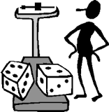
If the probability of an event occurring is Y, then the probability of the event not occurring is 1-Y. (Example: If the probability of an event is 0.80 (80%), then the probability that the event will not occur is 1-0.80 = 0.20, or 20%.
The odds of an event represent the ratio of the (probability that the event will occur) / (probability that the event will not occur). This could be expressed as follows:
Odds of event = Y / (1-Y)
So, in this example, if the probability of the event occurring = 0.80, then the odds are 0.80 / (1-0.80) = 0.80/0.20 = 4 (i.e., 4 to 1).
- If a race horse runs 100 races and wins 25 times and loses the other 75 times, the probability of winning is 25/100 = 0.25 or 25%, but the odds of the horse winning are 25/75 = 0.333 or 1 win to 3 loses.
- If the horse runs 100 races and wins 5 and loses the other 95 times, the probability of winning is 0.05 or 5%, and the odds of the horse winning are 5/95 = 0.0526.
- If the horse runs 100 races and wins 50, the probability of winning is 50/100 = 0.50 or 50%, and the odds of winning are 50/50 = 1 (even odds).
- If the horse runs 100 races and wins 80, the probability of winning is 80/100 = 0.80 or 80%, and the odds of winning are 80/20 = 4 to 1.
NOTE that when the probability is low, the odds and the probability are very similar.
With the case-control design we cannot compute the probability of disease in each of the exposure groups; therefore, we cannot compute the relative risk. However, we can compute the odds of disease in each of the exposure groups, and we can compare these by computing the odds ratio. In the hypothetical pesticide study the odds ratio is
OR= (7/10) / (5/57) = 6.65
Notice that this odds ratio is very close to the RR that would have been obtained if the entire source population had been analyzed. The explanation for this is that if the outcome being studied is fairly uncommon, then the odds of disease in an exposure group will be similar to the probability of disease in the exposure group. Consequently, the odds ratio provides a relative measure of effect for case-control studies, and it provides an estimate of the risk ratio in the source population, provided that the outcome of interest is uncommon.
We emphasized that in case-control studies the only measure of association that can be calculated is the odds ratio. However, in cohort-type studies, which are defined by following exposure groups to compare the incidence of an outcome, one can calculate both a risk ratio and an odds ratio.

- KT1005 Probability:
    - Why probability matters
    - Odds
Probability provides information about the likelihood that something will happen. Meteorologists, for instance, use weather patterns to predict the probability of rain. In epidemiology, probability theory is used to understand the relationship between exposures and the risk of health effects.

Odds
Odds provide a measure of the likelihood of a particular outcome. They are calculated as the ratio of the number of events that produce that outcome to the number that do not. Odds are commonly used in gambling and statistics.
Odds can be demonstrated by examining rolling a six-sided die. The odds of rolling a 6 is 1:5. This is because there is 1 event (rolling a 6) that produces the specified outcome of "rolling a 6", and 5 events that do not (rolling a 1,2,3,4 or 5). The odds of rolling either a 5 or 6 is 2:4. This is because there are 2 events (rolling a 5 or 6) that produce the specified outcome of "rolling either a 5 or 6", and 4 events that do not (rolling a 1, 2, 3 or 4). The odds of not rolling a 5 or 6 is the inverse 4:2. This is because there are 4 events that produce the specified outcome of "not rolling a 5 or 6" (rolling a 1, 2, 3 or 4) and two that do not (rolling a 5 or 6).
The probability of an event is different, but related, and can be calculated from the odds, and vice versa. The probability of rolling a 5 or 6 is the fraction of the number of events over total events or 2/(2+4), which is 1/3, 0.33 or 33%.
When gambling, odds are often the ratio of winnings to the stake and you also get your wager returned. So wagering 1 at 1:5 pays out 6 (5 + 1). If you make 6 wagers of 1, and win once and lose 5 times, you will be paid 6 and finish square. Wagering 1 at 1:1 (Evens) pays out 2 (1 + 1) and wagering 1 at 1:2 pays out 3 (1 + 2). These examples may be displayed in many different forms:
- Fractional odds with a slash: 5 (5/1 against), 1/1 (Evens), 1/2 (on) (short priced horse).
- Tote boards use decimal or Continental odds (the ratio of total paid out to stake), e.g. 6.0, 2.0, 1.5
- In the US Moneyline a positive number lists winnings per $100 wager; a negative number the amount to wager in order to win $100 on a short-priced horse: 500, 100/–100, –200.

Probability theory is the mathematical framework that allows us to analyze chance events in a logically sound manner. The probability of an event is a number indicating how likely that event will occur. This number is always between 0 and 1, where 0 indicates impossibility and 1 indicates certainty.

- KT1006 The Bayes rule:
    - Essential probability theorem
    - How odds change
    - Bayes rule in practice
    - Naïve Bayes classification

What is Bayes’ Theorem?
Bayes’ theorem is a way to figure out conditional probability. Conditional probability is the probability of an event happening, given that it has some relationship to one or more other events. For example, your probability of getting a parking space is connected to the time of day you park, where you park, and what conventions are going on at any time. Bayes’ theorem is slightly more nuanced. In a nutshell, it gives you the actual probability of an event given information about tests.
- “Events” Are different from “tests.” For example, there is a test for liver disease, but that’s separate from the event of actually having liver disease.
- Tests are flawed: just because you have a positive test does not mean you actually have the disease. Many tests have a high false positive rate. Rare events tend to have higher false positive rates than more common events. We’re not just talking about medical tests here. For example, spam filtering can have high false positive rates. Bayes’ theorem takes the test results and calculates your real probability that the test has identified the event.

In statistics, naive Bayes classifiers are a family of simple "probabilistic classifiers" based on applying Bayes' theorem with strong (naive) independence assumptions between the features (see Bayes classifier). They are among the simplest Bayesian network models,but coupled with kernel density estimation, they can achieve high accuracy levels.

Naive Bayes classifiers are highly scalable, requiring a number of parameters linear in the number of variables (features/predictors) in a learning problem. Maximum-likelihood training can be done by evaluating a closed-form expression,: 718 which takes linear time, rather than by expensive iterative approximation as used for many other types of classifiers.

In the statistics literature, naive Bayes models are known under a variety of names, including simple Bayes and independence Bayes.[5] All these names reference the use of Bayes' theorem in the classifier's decision rule, but naive Bayes is not (necessarily) a Bayesian method.

- KT1007 What are parameters
A parameter is a quantity that influences the output or behavior of a mathematical object but is viewed as being held constant. Parameters are closely related to variables, and the difference is sometimes just a matter of perspective.

To find the perimeter of a rectangle or square you have to add the lengths of all the four sides. x is in this case the length of the rectangle while y is the width of the rectangle. The area is measurement of the surface of a shape.

Calculating the area and the perimeter
The perimeter is the length of the outline of a shape. To find the perimeter of a rectangle or square you have to add the lengths of all the four sides. x is in this case the length of the rectangle while y is the width of the rectangle.
The perimeter, P, is:
P=x+x+y+yP=x+x+y+y
P=2x+2yP=2x+2y
P=2(x+y)P=2(x+y)
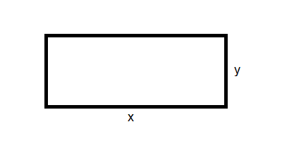
Example
Find the perimeter of this rectangle:
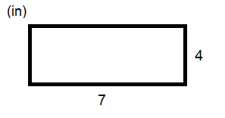
P=7+7+4+4P=7+7+4+4
P=2⋅7+2⋅4P=2⋅7+2⋅4
P=2⋅(7+4)P=2⋅(7+4)
P=2⋅11P=2⋅11
P=22inP=22in
The area is measurement of the surface of a shape. To find the area of a rectangle or a square you need to multiply the length and the width of a rectangle or a square.
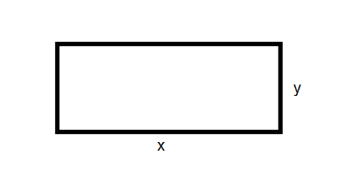
Area, A, is x times y.
A=x⋅yA=x⋅y
Example
Find the area of this square.
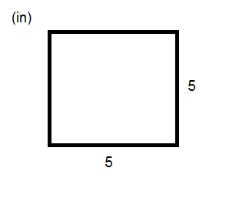
A=x⋅yA=x⋅y
A=5⋅5A=5⋅5
A=25in2A=25in2
There are different units for perimeter and area The perimeter has the same units as the length of the sides of rectangle or square whereas the area's unit is squared.

- KT1008 Estimating parameters
Parameter estimation is defined as the experimental determination of values of parameters that govern the system behavior, assuming that the structure of the process is known.

What is estimating parameters in statistics?

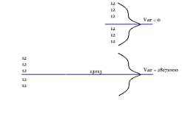

Parameter Estimation is a branch of statistics that involves using sample data to estimate the parameters of a distribution.

What is a parameter estimate (also called a sample statistic)?
Parameters are descriptive measures of an entire population. However, their values are usually unknown because it is infeasible to measure an entire population. Because of this, you can take a random sample from the population to obtain parameter estimates. One goal of statistical analyses is to obtain estimates of the population parameters along with the amount of error associated with these estimates. These estimates are also known as sample statistics.
There are several types of parameter estimates:
- Point estimates are the single, most likely value of a parameter. For example, the point estimate of population mean (the parameter) is the sample mean (the parameter estimate).
- Confidence intervals are a range of values likely to contain the population parameter.
For an example of parameter estimates, suppose you work for a spark plug manufacturer that is studying a problem in their spark plug gap. It would be too costly to measure every single spark plug that is made. Instead, you randomly sample 100 spark plugs and measure the gap in millimeters. The mean of the sample is 9.2. This is the point estimate for the population mean (μ), and it informs you that the most likely value for the average gap for all spark plugs is 9.2 You also create a 95% confidence interval for μ which is (8.8, 9.6). This means that you can be 95% confident that the true value of the average gap for all the spark plugs is between 8.8 and 9.6.

- KT1009 Conditional probability
Conditional probability: p(A|B) is the probability of event A occurring, given that event B occurs. For example, given that you drew a red card, what's the probability that it's a four (p(four|red))=2/26=1/13. So out of the 26 red cards (given a red card), there are two fours so 2/26=1/13.

How do you explain conditional probability?
The conditional probability of an event B is the probability that the event will occur given the knowledge that an event A has already occurred. This probability is written P(B|A), notation for the probability of B given A.

What is the formula for conditional probability?

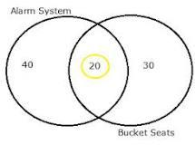

The formula for conditional probability is derived from the probability multiplication rule, P(A and B) = P(A)*P(B|A). You may also see this rule as P(A∪B). The Union symbol (∪) means “and”, as in event A happening and event B happening.

- KT1010 Essential probability theorems for ML
Definition
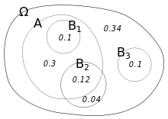
Illustration of conditional probabilities with an Euler diagram. The unconditional probability P(A) = 0.30 + 0.10 + 0.12 = 0.52. However, the conditional probability P(A|B₁) = 1, P(A|B₂) = 0.12 ÷ (0.12 + 0.04) = 0.75, and P(A|B₃) = 0.
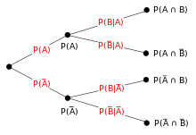
On a tree diagram, branch probabilities are conditional on the event associated with the parent node. (Here, the overbars indicate that the event does not occur.)
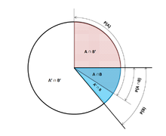
Venn Pie Chart describing conditional probabilities
Conditioning on an event
Kolmogorov definition
Given two events A and B from the sigma-field of a probability space, with the unconditional probability of B being greater than zero (i.e., P(B) > 0), the conditional probability of A given B () is the probability of A occurring if B has or is assumed to have happened. A is assumed to a set of all possible outcomes of an experiment or random trial that has a restricted or reduced sample space. The conditional probability can be found by the quotient of the probability of the joint intersection of events A and B () -- the probability at which A and B occur together, although not necessarily occurring at the same time-- and the probability of B:

The probability of an event can be calculated directly by counting all the occurrences of the event and dividing them by the total possible outcomes of the event. Probability is a fractional value and has a value in the range between 0 and 1, where 0 indicates no probability and 1 represents full probability.

What math do you need for ML?

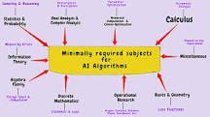

Machine learning is powered by four critical concepts and is Statistics, Linear Algebra, Probability, and Calculus. While statistical concepts are the core part of every model, calculus helps us learn and optimize a model.

Internal Assessment Criteria and Weight
• IAC1001 The definition of probabilities is understood and the applications thereof described
• IAC1002The basic Bayes rule is understood and described

SECTION 11: KM-02-KT11: Statistics
Learning Outcome
- KT1101 Why is statistics important in AI?
- KT1102 Introduction to statistics:
    - Descriptive statistics
    - Inferential statistics
- KT1103 Qualitative and quantitative research:
    - Definitions
    - Application
- KT1104 Statistics and machine learning:
    - Statistics in data preparation
    - Outlier detection
    - Missing value imputation
    - Data sampling
    - Data scaling
    - Variable encoding
    - Statistics in model evaluation
    - Data sampling
    - Data resampling
    - Experimental design
    - Statistics in model selection
    - Checking for a significant difference between results
    - Quantifying the size of the difference between results
    - Statistics in model prediction
    - Summarizing the expected skill of the model on average
    - Quantifying the expected variability of the skill of the model in practice
    - Statistics in model presentation
  - Quantifying the expected variability for the prediction
- KT1105 Gaussian distribution and descriptive statistics:
  - Mean
  - Variance
  - Standard deviation
- KT1106 Correlation between variables:
  - Positive correlation
  - Neutral correlation
  - Negative correlation
- KT1107 Statistical Hypothesis Tests:
  - Hypothesis 0 (H0)
  - Hypothesis 1 (H1)
- KT1108 Estimation statistics:
  - Classes of methods
  - Effect size
  - Interval estimation
  - Meta-analysis
- KT1109 Types of intervals:
  - Tolerance interval
  - Confidence interval
  - Prediction interval
- KT1110 Nonparametric statistics

- KT1101 Why is statistics important in AI?
How do statistics play a role in the field of AI? Statistics serve as a foundation for analysis and dealing with data in data science. A lot of performance metrics used in machine learning algorithms like accuracy, precision, recall, f-score, root mean squared error, etc. use statistics as the base.

What is statistics in Artificial Intelligence?
Statistics is a collection of tools that you can use to get answers to important questions about data. You can use descriptive statistical methods to transform raw observations into information that you can understand and share.

Why is statistics important in machine learning?
Statistics is a core component of data analytics and machine learning. It helps you analyze and visualize data to find unseen patterns. If you are interested in machine learning and want to grow your career in it, then learning statistics along with programming should be the first step.

Do you need statistics for AI?
Statistics & Probability Concepts You Need to Know for AI
Basic Statistics — Mean, median, mode, variance, covariance, and so on. Basic rules in probability — events (dependent and independent), sample spaces, conditional probability.

- KT1102 Introduction to statistics:
    - Descriptive statistics
    - Inferential statistics

What Are Descriptive Statistics?
Descriptive statistics are brief descriptive coefficients that summarize a given data set, which can be either a representation of the entire population or a sample of a population. Descriptive statistics are broken down into measures of central tendency and measures of variability (spread). Measures of central tendency include the mean, median, and mode, while measures of variability include standard deviation, variance, minimum and maximum variables, kurtosis, and skewness.

What is Inferential Statistics?
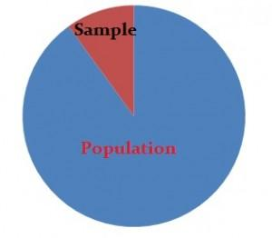
Descriptive statistics describes data (for example, a chart or graph) and inferential statistics allows you to make predictions (“inferences”) from that data. With inferential statistics, you take data from samples and make generalizations about a population.
For example, you might stand in a mall and ask a sample of 100 people if they like shopping at Sears. You could make a bar chart of yes or no answers (that would be descriptive statistics) or you could use your research (and inferential statistics) to reason that around 75-80% of the population (all shoppers in all malls) like shopping at Sears.

- KT1103 Qualitative and quantitative research:
    - Definitions
    - Application

Qualitative research
Qualitative research relies on data obtained by the researcher from first-hand observation, interviews, questionnaires (on which participants write descriptively), focus groups, participant-observation, recordings made in natural settings, documents, and artifacts. The data are generally nonnumerical. Qualitative methods include ethnography, grounded theory, discourse analysis, and interpretative phenomenological analysis.[1] Qualitative research methods have been used in sociology, anthropology, political science, psychology, social work, and educational research.[2][3] Qualitative researchers study individuals' understanding of their social reality.

Quantitative research.

Quantitative research is a research strategy that focuses on quantifying the collection and analysis of data.[1] It is formed from a deductive approach where emphasis is placed on the testing of theory, shaped by empiricist and positivist philosophies.

Associated with the natural, applied, formal, and social sciences this research strategy promotes the objective empirical investigation of observable phenomena to test and understand relationships. This is done through a range of quantifying methods and techniques, reflecting on its broad utilization as a research strategy across differing academic disciplines.
The objective of quantitative research is to develop and employ mathematical models, theories, and hypotheses pertaining to phenomena. The process of measurement is central to quantitative research because it provides the fundamental connection between empirical observation and mathematical expression of quantitative relationships.
Quantitative data is any data that is in numerical form such as statistics, percentages, etc.[4] The researcher analyses the data with the help of statistics and hopes the numbers will yield an unbiased result that can be generalized to some larger population. Qualitative research, on the other hand, inquires deeply into specific experiences, with the intention of describing and exploring meaning through text, narrative, or visual-based data, by developing themes exclusive to that set of participants.
Quantitative research is widely used in psychology, economics, demography, sociology, marketing, community health, health & human development, gender studies, and political science; and less frequently in anthropology and history. Research in mathematical sciences, such as physics, is also "quantitative" by definition, though this use of the term differs in context. In the social sciences, the term relates to empirical methods originating in both philosophical positivism and the history of statistics, in contrast with qualitative research methods.
Qualitative research produces information only on the particular cases studied, and any more general conclusions are only hypotheses. Quantitative methods can be used to verify which of such hypotheses are true. A comprehensive analysis of 1274 articles published in the top two American sociology journals between 1935 and 2005 found that roughly two-thirds of these articles used quantitative method.

What is difference between qualitative and quantitative research?


Quantitative research deals with numbers and statistics, while qualitative research deals with words and meanings. Quantitative methods allow you to systematically measure variables and test hypotheses. Qualitative methods allow you to explore concepts and experiences in more detail.

- KT1104 Statistics and machine learning:
    - Statistics in data preparation
    - Outlier detection
    - Missing value imputation
    - Data sampling
    - Data scaling
    - Variable encoding
    - Statistics in model evaluation
    - Data sampling
    - Data resampling
    - Experimental design
    - Statistics in model selection
    - Checking for a significant difference between results
    - Quantifying the size of the difference between results
    - Statistics in model prediction
    - Summarizing the expected skill of the model on average
    - Quantifying the expected variability of the skill of the model in practice
    - Statistics in model presentation
  - Quantifying the expected variability for the prediction

Statistics is a core component of data analytics and machine learning. It helps you analyze and visualize data to find unseen patterns. If you are interested in machine learning and want to grow your career in it, then learning statistics along with programming should be the first step.

What is machine learning and how statistics is used in machine learning?

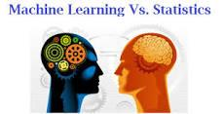

Machine Learning is an algorithm that can learn from data without relying on rules-based programming. Statistical modeling is a formalization of relationships between variables in the data in the form of mathematical equations.

The difference between machine learning and statistics has been the subject of long-running debate. A debate so contentious at times, that it has even become the subject of memes.
Some say that machine learning is just glorified statistics, rebranded for the age of big data and faster computing. Others say that they’re completely unrelated, so much so that you don’t even need to understand statistics to perform machine learning tasks.
So who’s right? As you can imagine, the reality falls somewhere between these two extremes.
The goal of this blog is to:
- Define statistics and machine learning.
- Explain how each discipline related to the other.

What is statistics?
The Department of Statistics at the University of California, Irvine defines the discipline as “the science concerned with developing and studying methods for collecting, analyzing, interpreting and presenting empirical data.”
Statistics has been studied and used for more than a thousand years, with the first writings on the subject dating back to the 8th century. There are two main statistical methods: descriptive statistics and inferential statistics.
Descriptive statistics is the process of summarizing information about a sample using metrics like mean, median, mode, standard deviation, etc. This is sometimes used for exploratory data analysis leading to a larger project, or descriptive statistics may be the extent of the investigation.
Inferential statistics is the process of inferring properties on a population based on the properties of a sample of a population.

What is machine learning?
Machine learning is a subset of artificial intelligence. It is the process of computers using large amounts of data to find patterns and make decisions without human intervention. Machine learning is used for tasks like text mining and sentiment analysis.
There are three methods of machine learning: supervised learning, unsupervised learning, and reinforcement learning. In supervised learning there is a target outcome variable. In unsupervised learning, there is no target and the machine is simply finding patterns and relationships within the data. The process of reinforcement learning involves an algorithm using trial and error to reach an objective.
While not centuries old, machine learning is not new and has been researched extensively since the 1950s. It has come into prominence in the past two decades due to the exponential growth in data collection and increased computing power.

How are statistics and machine learning related?
Many machine learning techniques are drawn from statistics (e.g., linear regression and logistic regression), in addition to other disciplines like calculus, linear algebra, and computer science. But it is this association with underlying statistical techniques that causes many people to conflate the disciplines.
Interestingly, newer machine learning engineers and data scientists who use machine learning packages like scikit-learn in Python may be unaware of the underlying relationship between machine learning and statistics.
This abstraction of machine learning from statistics with the use of libraries is often why some individuals make the argument that knowledge of statistics is not necessary to do machine learning. While this may be true for more basic tasks, experienced data scientists and machine learning engineers draw on their knowledge probability and statistics to develop models.

What are the key differences between statistics and machine learning?
Purpose
Statistics and machine learning often get lumped together because they use similar means to reach a goal. However, the goals that they are trying to achieve are very different. The purpose of statistics is to make an inference about a population based on a sample. Machine learning is used to make repeatable predictions by finding patterns within data.

Data
Machine learning requires large amounts of data in order to make accurate predictions. Models are built using training data, fine tuned using a validation dataset, and are evaluated with a test dataset. All of these steps help the machine “learn.”
Statistics does not involve multiple subsets of data because you are not trying to make a prediction. The point of modeling in this situation is to display the relationship between data and the outcome variable. In addition, statistics relies on significance tests to determine the direction and magnitude of a relationship, discounting noise and confounding variables.

Interpretability
Because of the large number of variables in machine learning datasets, the models developed from them can be simultaneously extremely accurate and almost impossible to understand. Statistical models, on the other hand are typically easier to understand because they are based on fewer variables, and the accuracy of relationships is supported by tests of statistical significance.

Is one more valuable than the other?
No. You really can’t place a value judgment on two disciplines that serve different purposes. The choice to develop a machine learning model or a statistical model will depend on your goal or industry.
One important factor to consider is interpretability, as mentioned earlier. A data scientist may not need to justify the decisions of a complicated model that gives recommendations about how many widgets to manufacture. However, a model meant to make more sensitive decisions (e.g., granting or denying a loan) may not be acceptable if a data scientist can’t prove the strength of relationships between the predictors and the outcome variable.

Where do data science and AI fit into the picture?
While we’ve mentioned both terms already in this piece, we think it’s important to explicitly define how data science and artificial intelligence (AI) fit into the statistics/machine learning debate.
Artificial intelligence is a branch of computer science focused on building machines capable of performing tasks typically done by humans. Machine learning is a subset of this field.
Data science is a multidisciplinary field that includes aspects of computer science, math, statistics, and machine learning to derive insights from large data sets. Data scientists work to solve problems or uncover opportunities using the vast amounts of data that companies and governments generate. They often draw upon their knowledge of statistics to aid them in developing models most appropriate for the task.

- KT1105 Gaussian distribution and descriptive statistics:
  - Mean
  - Variance
  - Standard deviation
Descriptive statistics summarize and organize characteristics of a data set. A data set is a collection of responses or observations from a sample or entire population.

In quantitative research, after collecting data, the first step of statistical analysis is to describe characteristics of the responses, such as the average of one variable (e.g., age), or the relation between two variables (e.g., age and creativity).

The next step is inferential statistics, which help you decide whether your data confirms or refutes your hypothesis and whether it is generalizable to a larger population.

Descriptive statistics allow you to characterize your data based on its properties. There are four major types of descriptive statistics:
1. Measures of Frequency:
* Count, Percent, Frequency
* Shows how often something occurs
* Use this when you want to show how often a response is given
2. Measures of Central Tendency
* Mean, Median, and Mode
* Locates the distribution by various points
* Use this when you want to show how an average or most commonly indicated response
3. Measures of Dispersion or Variation
* Range, Variance, Standard Deviation
* Identifies the spread of scores by stating intervals
* Range = High/Low points
* Variance or Standard Deviation = difference between observed score and mean
* Use this when you want to show how "spread out" the data are. It is helpful to know when your data are so spread out that it affects the mean
4. Measures of Position
* Percentile Ranks, Quartile Ranks
* Describes how scores fall in relation to one another. Relies on standardized scores
* Use this when you need to compare scores to a normalized score (e.g., a national norm)

The normal distribution is one of the most important concepts in statistics since nearly all statistical tests require normally distributed data. It basically describes how large samples of data look like when they are plotted. It is sometimes called the “bell curve“ or the “Gaussian curve“.

What is special about Gaussian distribution?
Gaussian Distribution and its key characteristics:
Gaussian distribution is a continuous probability distribution with symmetrical sides around its center. Its mean, median and mode are equal. Its shape looks like below with most of the data points clustered around the mean with asymptotic tails.

What is meant by Gaussian distribution?
What is Normal Distribution? Normal distribution, also known as the Gaussian distribution, is a probability distribution that is symmetric about the mean, showing that data near the mean are more frequent in occurrence than data far from the mean. In graph form, normal distribution will appear as a bell curve.

Why is it called a Gaussian distribution?

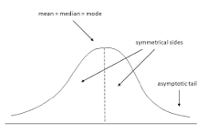

The normal distribution is often called the bell curve because the graph of its probability density looks like a bell. It is also known as called Gaussian distribution, after the German mathematician Carl Gauss who first described it.

- KT1106 Correlation between variables:
  - Positive correlation
  - Neutral correlation
  - Negative correlation

The statistical relationship between two variables is referred to as their correlation. A correlation could be positive, meaning both variables move in the same direction, or negative, meaning that when one variable's value increases, the other variables' values decrease.

How do you find the correlation between two variables?
The correlation coefficient is determined by dividing the covariance by the product of the two variables' standard deviations. Standard deviation is a measure of the dispersion of data from its average. Covariance is a measure of how two variables change together.

What is an example of correlation between two variables?

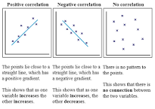

An example of positive correlation would be height and weight. Taller people tend to be heavier. A negative correlation is a relationship between two variables in which an increase in one variable is associated with a decrease in the other.

What are the 4 types of correlation?
Usually, in statistics, we measure four types of correlations: Pearson correlation, Kendall rank correlation, Spearman correlation, and the Point-Biserial correlation.

What is Karl Pearson coefficient of correlation?

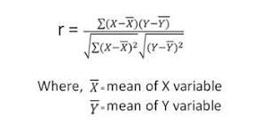

Karl Pearson's coefficient of correlation is defined as a linear correlation coefficient that falls in the value range of -1 to +1. Value of -1 signifies strong negative correlation while +1 indicates strong positive correlation.

- KT1107 Statistical Hypothesis Tests:
Hypothesis testing is an act in statistics whereby an analyst tests an assumption regarding a population parameter. The methodology employed by the analyst depends on the nature of the data used and the reason for the analysis. Hypothesis testing is used to assess the plausibility of a hypothesis by using sample data.
What Is Hypothesis Testing?
Hypothesis testing is an act in statistics whereby an analyst tests an assumption regarding a population parameter. The methodology employed by the analyst depends on the nature of the data used and the reason for the analysis.

Hypothesis testing is used to assess the plausibility of a hypothesis by using sample data. Such data may come from a larger population, or from a data-generating process. The word "population" will be used for both of these cases in the following descriptions.
How Hypothesis Testing Works
In hypothesis testing, an analyst tests a statistical sample, with the goal of providing evidence on the plausibility of the null hypothesis.

Statistical analysts test a hypothesis by measuring and examining a random sample of the population being analyzed. All analysts use a random population sample to test two different hypotheses: the null hypothesis and the alternative hypothesis.

The null hypothesis is usually a hypothesis of equality between population parameters; e.g., a null hypothesis may state that the population mean return is equal to zero. The alternative hypothesis is effectively the opposite of a null hypothesis (e.g., the population mean return is not equal to zero). Thus, they are mutually exclusive, and only one can be true. However, one of the two hypotheses will always be true.

- KT1108 Estimation statistics:
Estimation statistics, or simply estimation, is a data analysis framework that uses a combination of effect sizes, confidence intervals, precision planning, and meta-analysis to plan experiments, analyze data and interpret results.

Classes of Methods
1. Descriptive Statistics:
- Purpose: Summarizes and describes the main features of a dataset. It provides a clear overview of the data without making inferences about the larger population.
- Common Techniques:
  - Measures of Central Tendency: Mean (average), median (middle value), and mode (most frequent value).
  - Measures of Dispersion: Range (difference between the maximum and minimum values), variance (average of squared deviations from the mean), and standard deviation (square root of variance).
  - Frequency Distribution: Table or graph showing the number of observations within each interval of a variable.
2. Inferential Statistics:
- Purpose: Makes inferences or predictions about a population based on a sample of data. It helps to draw conclusions and make decisions based on statistical evidence.
- Common Techniques:
  - Hypothesis Testing: Procedure to test assumptions or claims about a population parameter. Common tests include t-tests, chi-square tests, and ANOVA.
  - Estimation: Estimating population parameters (e.g., mean, proportion) from sample statistics.
  - Regression Analysis: Examines relationships between variables, including simple linear regression and multiple regression.
3. Bayesian Statistics:
- Purpose: Uses Bayes' theorem to update the probability of a hypothesis as more evidence or information becomes available.
- Key Concepts:
  - Prior Probability: Initial estimate of the probability of an event before new data is considered.
  - Posterior Probability: Updated probability after considering new evidence.
  - Bayesian Inference: Methods for estimating the parameters of a statistical model using Bayesian principles.
4. Non-parametric Methods:
- Purpose: Makes fewer assumptions about the distribution of the data and is useful for ordinal data or when the data does not meet the assumptions of parametric tests.
- Common Techniques:
  - Mann-Whitney U Test: Tests differences between two independent groups.
  - Wilcoxon Signed-Rank Test: Tests differences between two related samples.
  - Kruskal-Wallis Test: Tests differences between more than two independent groups.
5. Multivariate Methods:
- Purpose: Analyzes data involving multiple variables to understand relationships and patterns.
- Common Techniques:
  - Principal Component Analysis (PCA): Reduces the dimensionality of data while preserving as much variance as possible.
  - Factor Analysis: Identifies underlying factors that explain the pattern of correlations among variables.
  - Cluster Analysis: Groups similar observations together based on their characteristics.

Effect Size
1. Definition:
- Effect Size: A quantitative measure of the strength or magnitude of a relationship or difference between groups. It provides a more informative understanding of the practical significance of findings beyond p-values.
2. Types of Effect Sizes:
- Cohen’s d: Measures the standardized difference between two means. It is calculated as the difference between the means divided by the pooled standard deviation.
  - Interpretation: Small (0.2), medium (0.5), and large (0.8) effect sizes.
- Pearson’s r: Measures the strength and direction of the linear relationship between two variables.
  - Interpretation: Ranges from -1 to +1, with 0 indicating no correlation.
- Eta-squared (η²): Represents the proportion of variance in the dependent variable that is attributable to the independent variable in ANOVA.
  - Interpretation: Small (0.01), medium (0.06), and large (0.14) effect sizes.
- Odds Ratio (OR): Used in binary outcome studies to measure the odds of an event occurring in one group compared to another.
  - Interpretation: OR > 1 indicates increased odds, OR < 1 indicates decreased odds.
3. Importance:
- Practical Significance: Effect size provides a measure of practical significance that complements statistical significance. It helps in understanding the magnitude of an effect and its relevance in real-world applications.
- Comparative Analysis: Effect sizes allow for comparison across studies with different sample sizes and measurement scales.

Interval Estimation
1. Definition:
- Interval Estimation: Provides a range of values (confidence interval) within which a population parameter is likely to fall with a certain level of confidence.
2. Confidence Intervals (CIs):
- Confidence Level: Indicates the probability that the interval contains the true population parameter (e.g., 95% CI means there is a 95% chance that the interval includes the true parameter).
- Calculation:
  - For means, CI is typically calculated as Mean±(Z×Standard Error)\text{Mean} \pm (Z \times \text{Standard Error})Mean±(Z×Standard Error) where ZZZ is the Z-score corresponding to the confidence level.
  - For proportions, CI is calculated using the formula p^±(Z×p^(1−p^)n)\hat{p} \pm (Z \times \sqrt{\frac{\hat{p}(1-\hat{p})}{n}})p^​±(Z×np^​(1−p^​)​​), where p^\hat{p}p^​ is the sample proportion and nnn is the sample size.
3. Interpretation:
- Range of Estimates: Provides a range that likely contains the true population parameter, offering a measure of precision and reliability.
- Wider Intervals: Typically result from smaller sample sizes or greater variability, indicating less precision in the estimate.
4. Use Cases:
- Scientific Research: Helps in reporting results and understanding the uncertainty of estimates.
- Decision-Making: Assists in making informed decisions by providing an estimate range rather than a single point.

Meta-Analysis
1. Definition:
- Meta-Analysis: A statistical technique for combining results from multiple studies to obtain a more accurate and generalizable estimate of the effect size or relationship being investigated.
2. Steps in Meta-Analysis:
- Literature Search: Identifying and selecting relevant studies based on predefined criteria.
- Data Extraction: Collecting data from the selected studies, including effect sizes, sample sizes, and other relevant information.
- Statistical Analysis: Combining effect sizes using techniques such as fixed-effects or random-effects models to calculate an overall effect size.
- Heterogeneity Assessment: Evaluating the variability between study results using statistics like I² and Q-tests.
3. Advantages:
- Increased Power: Combining data from multiple studies increases the sample size and statistical power, improving the precision of the estimates.
- Generalizability: Provides a more comprehensive understanding of the effect by aggregating results from different contexts and populations.
- Identification of Patterns: Helps in identifying patterns, sources of variation, and potential moderators affecting the effect size.
4. Limitations:
- Study Quality: The quality of the meta-analysis is dependent on the quality of the included studies. Poor-quality studies can affect the overall results.
- Publication Bias: Studies with significant or positive results are more likely to be published, potentially skewing the results of the meta-analysis.
5. Use Cases:
- Medical Research: Commonly used to synthesize findings from clinical trials and observational studies.
- Social Sciences: Helps in aggregating results from various studies to draw broader conclusions about social phenomena.

- KT1109 Types of intervals:
Prediction interval to contain all or most of these observations from a future sample. Confidence interval for the probability of being less than (or greater than) some specified value. Prediction interval to contain the proportion of observations in a future sample that exceed a specified limit.

What are interval in statistics?



Interval data is measured along a numerical scale that has equal distances between adjacent values. These distances are called “intervals.” There is no true zero on an interval scale, which is what distinguishes it from a ratio scale.

What is interval data type?



Interval data, also called an integer, is defined as a data type which is measured along a scale, in which each point is placed at equal distance from one another. Interval data always appears in the form of numbers or numerical values where the distance between the two points is standardized and equal.

What are the examples of interval?

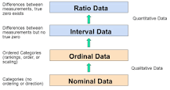

An interval scale is one where there is order and the difference between two values is meaningful. Examples of interval variables include: temperature (Farenheit), temperature (Celcius), pH, SAT score (200-800), credit score (300-850).

- KT1110 Nonparametric statistics

Nonparametric statistics refers to a statistical method in which the data are not assumed to come from prescribed models that are determined by a small number of parameters; examples of such models include the normal distribution model and the linear regression model.

What are examples of nonparametric statistics?
An example of this type of data is age, income, height, and weight in which the values are continuous and the intervals between values have meaning. In contrast, nonparametric statistics are typically used on data that nominal or ordinal. Nominal variables are variables for which the values have not quantitative value.

Internal Assessment Criteria and Weight

- IAC1101 The definition and importance of statistics are understood and described
- IAC1102 The definition of qualitative and quantitative research is understood and the applications thereof described
- IAC1103 The application of statistics in machine learning is understood and described
- IAC1104 The application of statistics in preparation is understood and described
- IAC1105 The application of statistics in model evaluation is understood and described
- IAC1106 The application of statistics in model selection is understood and described
- IAC1107 The application of statistics in model preparation is understood and described
- IAC1108 Gaussian distribution and description statistics are understood and described
- IAC1109 The correlation between variables is understood and described
- IAC1110 Statistical hypothesis is understood and successfully used
- IAC1111 Estimation statistics is understood and successfully used
- IAC1112 Types of intervals are understood and described
- IAC1113 Nonparametric statistics is understood and described

SECTION 12: KM-02-KT12:Bayes’ Theorem
Learning Outcome
- KT1201 Bayes’ theorem:
    - Bayes’ Theorem of conditional probability
    - Naming the terms in the theorem
    - Example for calculating Bayes’ Theorem
    - Diagnostic test scenario
    - Manual calculation
    - Python code calculation
    - Binary classifier terminology
    - Bayes’ Theorem for modelling Hypotheses
    - Bayes’ Theorem for classification
    - Bayes’ Classifier
    - Bayes’ Optimal Classifier
    - More uses of Bayes’ Theorem in Machine Learning
    - Bayesian optimisation
    - Bayesian belief networks

- KT1201 Bayes’ theorem:
    - Bayes’ Theorem of conditional probability
    - Naming the terms in the theorem
    - Example for calculating Bayes’ Theorem
    - Diagnostic test scenario
    - Manual calculation
    - Python code calculation
    - Binary classifier terminology
    - Bayes’ Theorem for modelling Hypotheses
    - Bayes’ Theorem for classification
    - Bayes’ Classifier
    - Bayes’ Optimal Classifier
    - More uses of Bayes’ Theorem in Machine Learning
    - Bayesian optimisation
    - Bayesian belief networks

Bayes' Theorem states that the conditional probability of an event, based on the occurrence of another event, is equal to the likelihood of the second event given the first event multiplied by the probability of the first event.

What is the term of theorem?
Definition of theorem
1 : a formula, proposition, or statement in mathematics or logic deduced or to be deduced from other formulas or propositions. 2 : an idea accepted or proposed as a demonstrable truth often as a part of a general theory : proposition the theorem that the best defense is offense.

Can Python be used as a calculator?
Python can be used as a calculator to compute arithmetic operations like addition, subtraction, multiplication and division. Python can also be used for trigonometric calculations and statistical calculations.

How do you solve math equations in Python?
To solve the two equations for the two variables x and y , we'll use SymPy's solve() function. The solve() function takes two arguments, a tuple of the equations (eq1, eq2) and a tuple of the variables to solve for (x, y) . The SymPy solution object is a Python dictionary.

Is Bayesian a hypothesis test?
Given two competing hypotheses and some relevant data, Bayesian hypothesis testing begins by specifying separate prior distributions to quantitatively describe each hypothesis. The combination of the likelihood function for the observed data with each of the prior distributions yields hypothesis-specific models.

Internal Assessment Criteria and Weight

• IAC1201 The Bayes Theorem of Conditional probability is understood and described
• IAC1202 The Bayes Theorem calculation is understood and described
• IAC1203 The Bayes Theorem is used for modelling a hypothesis and for classification
• IAC1204 The Bayes Theorem is used for Machine learning

Good Luck!

